Educational kit
E-mentoring: a new qualification for continuing education and training

Information about the project

eMentEdu
Project title:
E-mentoring: a new qualification for continuing education and training
Project number:
No. 2021-1-LV01-KA220-VET-000033122
Sub-programme or KA:
KA2 - Cooperation partnerships in vocational education and training
KA220 - VET: Adapting vocational education and training to labour market needs
Website: https://rta.lv/projekti/e-mentoring-a-new-qualification-for-continuing-education-and-training-01112021

CONSORTIUM:

Contents
Module 1 | Purpose and definition of e-mentoring |  | 3
Module 2 | E-mentoring: current and future trends |  | 20
Module 3 | E-mentoring training and coaching support |  | 25
Module 4 | Online individual interaction, Virtual teams |  | 51
Module 5 | E-mentoring software |  | 66
Educational kit

E-mentoring: a new qualification for continuing education and training

Module 1:
Purpose and definition of e-mentoring
Author(s):
Dr.sc. comm. Sandra Sprudzāne (Rezekne Academy of Technologies)
Dr.oec. Anda Zvaigzne (Rezekne Academy of Technologies)
Contents

1. | Purpose and definitions of e-mentoring | 5
2. | E-mentoring results | 8
3. | Communication in e-mentoring | 11
 | ACTIVITY 1 | 14
 | ACTIVITY 2 | 14
 | Bibliography | 15

1.Purpose and definition of e-mentoring
Keywords: mentor, mentee, e-mentoring, technology,
With technological progress and global and demographic change, the way we work, learn, participate in society and manage our daily lives is also changing (European Commission, 2020). Organisations and businesses are increasingly using a range of virtual opportunities, including knowledge transfer through mentoring. It is based on the informal transfer of knowledge, social capital and psychosocial support, in which the mentee receives from a mentor information that the mentee considers relevant to their work, career or professional development (Bozeman & Feeney, 2007). Ensher et al. (2002) defined mentoring as "... ... the thoughtful pairing of individuals with different backgrounds and skills, aimed at facilitating the growth of less experienced individuals and the development of their specific skills...". According to Clutterbuck (2005) and Megginson (2006), the mentor becomes a confidant and, by providing assistance, brings about a significant change in the mentee's level of knowledge, performance and mentality (Clutterbuck & Megginson, 2005). Pertin (2011) defined mentoring as a professional relationship in which a skilled person (mentor) helps another less skilled person, the mentee, to develop complex knowledge and skills that can contribute to the mentee's personal and professional development.
The common factor in all definitions of mentoring is that mentoring involves communication between two parties (Bozeman & Feeney, 2007):
1) One party transfers his/her knowledge and experience, i.e. the mentor,
2) and the other party taking over that knowledge and experience.
Mentoring is undergoing changes due to technological advances and is nowadays increasingly distinguished from e-mentoring, also referred to as telementoring, cybermentoring, virtual mentoring, online mentoring, internet mentoring, computer-based mentoring and e-mentoring (Adams & Crews, 2004); (Ensher et al, 2003); (Knouse, 2001); (Perren, 2003). E-mentoring is a process in which mentors assist their mentees through electronic communication channels (Hamilton & Scandura, 2003) or technology and has the same goals and outcomes as traditional mentoring (Neely et al., 2017). It enables the exchange of information in a digital environment using one or more digital platforms (McReynolds et al., 2020).
The active use of technology, in particular web-based networking, is generally assumed to be beneficial for career development and job opportunities. Individuals with extensive professional and business contacts are more likely to be aware of opportunities and better able to obtain the information they need (Feeney, Bozeman, 2008).
Clutterbuck & Lane (2004) point out that effective use of e-mentoring requires computer literacy, appropriate computer equipment, access to the internet, effective communication skills, accessibility, organisation of meetings, confidentiality of messages, willingness to receive feedback and the creation of a warm, honest and open environment (Kahraman & Kuzu, 2016).
^{thst}Although various technology-based mentoring programmes have been implemented for years, in the late 20th and early 21st centuries, e-mentoring was mainly used to implement mentoring programmes for specific groups in society, such as young people with disabilities, and programmes focusing on career development and sexual and gender minority issues. The aim of using such technologies was to build experiences discreetly, without the need for face-to-face meetings (Kaufman et al., 2020).
Nowadays, communication between mentor and mentee takes place via electronic platforms such as telephone, email, various online platforms or chat applications. This creates opportunities for mentors to develop more diverse mentoring relationships and to implement projects that are not limited by the geographical location of either the mentor or the mentee (Mahayosnand & Bermejo, 2021). Table 1 shows the media or communication channels most commonly used for e-mentoring today (Leck & Wood, 2013), but these are subject to change and addition due to technological developments.
Table 1. Description of e-mentoring tools
E-mentoring tools
No. | Media/communication channel | Benefits
1. | E-mail | The most commonly used e-mentoring tool
2. | Online discussion groups | The mentor has the possibility to contact several mentors at the same time.
3. | Online messages and chats | This allows you to contact
4. | Videoconferencing, communication | This personalises the mentoring process for the participants, without the need to travel long distances to meet.
5. | Blogs | This allows the mentor and mentee to share information publicly, allows other participants to take part in the process and to comment.
6. | Cloud computing services | It provides an opportunity to share and co-create a variety of information materials.
7. | Sharing documents | Mentors have the opportunity to share with the mentee the documents they have developed, and the mentee has the opportunity to share the learning content.
There are different options for the e-mentoring module platform, which is at the heart of the formal e-mentoring process. For this platform, where the e-mentoring process is coordinated, interactions are built and records are kept, one of the existing software can be chosen or new software can be developed. In addition, when choosing a platform, it is also important to learn how to manage the e-mentoring process. It is important to provide support for problems that might arise with both the software and the mentoring process. Therefore, when selecting a software, not only the basic features and necessary functionalities should be considered, but also the technical support that should be provided to ensure that the process runs as smoothly as possible and with the least problems (Kuzu et al., 2012).
As shown in Table 1, e-mentoring can be implemented using a variety of tools, media and technologies. For example, videoconferencing software offers a wealth of multimedia, multimedia synchronicity and allows participants to take full advantage of F2F communication, including instant feedback, non-verbal communication cues (e.g. body language), etc. (Neely et al., 2017).
Some researchers (Leck & Wood, 2013) point out that although technology is a tool that facilitates e-mentoring relationships, the process itself is enabled and sustained by the people who focus on the relationship. Mahayosnand P.P. and Bermejo D.M. (2021), who analysed e-mentoring during the Kovid-19 pandemic, concluded that building mentor-mentee relationships through electronic formats is unique and incomparable to traditional mentoring. These findings were confirmed by Neely A.R., Cotton J. and Neely A.D. Neely A.R. (Neely et al., 2017), who found that social media (e.g. Facebook, Twitter, LinkedIn) also facilitates e-mentoring relationships. Social media focused on topics related to personal communication and this could make them an ideal platform for mentor-mentee interactions. Some studies (Schneider, 2016); (Schwartz et al., 2014) found that the use of digital media, especially Facebook, contributed to a higher quality of relationship and influenced the duration of the mentor-mentee relationship.
Mentors often post biographical profiles, photos and other information on social media that can give insights into them as people. Technological solutions, such as email, do not contain such information. To summarise the findings of various researchers, the following key features of e-mentoring can be highlighted:
- quick and easy to organise;
- convenient for both parties;
- convenient in terms of time and location;
- no additional funds are needed
- e-mentors are more accessible - it's quick and easy to get in touch;
- more time to think and prepare the right answer;
- it is possible to discuss issues that would be embarrassing to disclose in F2f communication;
- informally;
- anonymity - it allows the defendant to give more honest answers, and some discussions are more manageable;
- have the opportunity to take part in informal discussions directly and indirectly relevant to the field;
- You can plan your work by setting time limits to complete a specific task;
- it's possible to make contacts all over the world;
- non-verbal signals are difficult to pick up;
- no immediate feedback on notifications;
- is a challenge to solve several problems, for example in the case of email;
- it's harder to establish relationships;
- the mentor's busy/work schedule could slow down feedback;
- must rely on the continuing interests of both parties.
2. E-mentoring results
Mentoring, both virtual and face-to-face, offers career development benefits. However, e-mentoring or virtual mentoring facilitates the interaction between individuals, taking into account the mentors' busy schedules, and removes the barriers associated with face-to-face meetings. Some researchers stress the importance of having multiple mentors interacting or having a network of mentors available so that mentees can receive advice, ideas and scientific and practical experience from multiple stakeholders, which is important for career development and problem solving (McReynolds et al., 2020).
In the academic literature, the benefits of e-mentoring include the opportunity for the mentor to expand their social and professional networks (Headlam-Wells et al., 2005); (Whiting & de Janasz, 2004) as well as their knowledge base, access to resources and job opportunities (Higgins & Thomas, 2001); (de Janasz et al., 2008). E-mentoring can also improve interpersonal communication skills (Adams & Crews, 2004), written communication skills (Brown & Dexter, 2002); (Fodeman, 2002); (Haas et al., 2002) and teamwork skills (Fodeman, 2002). E-mentoring relationships can also increase a mentee's self-esteem and productivity (Adams & Crews, 2004), as well as improve reflective skills (i.e. awareness of one's strengths) (Neely et al., 2017).
As a result of the integration of new technologies, e-mentoring is seen as a flexible alternative (sometimes complementary) to traditional face-to-face mentoring (de Janasz, 2013); (Murphy, 2011); (Shrestha et al., 2009); (Single & Single, 2005); (Kahraman & Kuzu, 2016). Although mentoring and e-mentoring are essentially about transferring knowledge and experience through technology, there are some differences (Neely et al., 2017).
Some researchers also consider the economic advantage of e-mentoring to be cost-effective (Mahayosnand et al., 2021) and that e-mentoring can create more equitable relationships between mentoring participants than traditional mentoring because online communication is more difficult to influence from the outside (Kasprisin et al., 2003). However, some researchers suggest that in the case of e-mentoring, mentees may pay less attention to the mentoring process than in the case of traditional mentoring relationships for various reasons (Stone & Lukaszewski, 2009). Also, in the case of e-mentoring, learners may not understand the information provided by the mentor during the online communication and have fewer opportunities to clarify the information received (Stone & Lukaszewski, 2009); (Neely et al., 2017).
Mentoring and e-mentoring differ mainly in the type of media used. Traditional face-to-face (F2F) mentoring involves face-to-face meetings in which the mentor and mentee meet physically and interact synchronously. In the case of e-mentoring, communication takes place via technology. Mentoring is often organised using both approaches or in a mixed or hybrid way, i.e. mentors and mentees meet face-to-face and use some online elements (e.g. email, social media, etc.) (Murphy, 2011); (Neely et al, 2017).
Therefore, two types of e-mentoring are distinguished: blended or hybrid e-mentoring and virtual e-mentoring, in which the technology fully supports the relationship between mentor and mentee (Neely et al., 2017).

Type of e-mentoring

Virtual / mixed or hybrid e-mentoring
Formal/informal e-mentoring
The collaborative process in e-mentoring

Mentors

Gender
Age
Perceptual similarity
Personality type (extrovert/introvert)
Personal proactivity

Mentee

Gender
Age
Perceptual similarity
Personality type (extrovert/introvert)
Personal proactivity

E-mentoring process

Contact
Communication tools and technological solutions
E-mentoring training

Figure 2. E-mentoring model (Source. Neely et al., 2017)
Researchers Neely A.R., Cotton J. and Neely A.D. have developed an operational e-mentoring model (Figure 1). It is based on three dimensions (Neely et al., 2017):
- Virtual e-mentoring, or a combination of both face-to-face and virtual elements of e-mentoring.
- Informal e-mentoring, where the mentor and mentee find each other and the relationship develops organically, or formal e-mentoring, where the relationship between mentor and mentee develops in an organised, formal mentoring programme.
- E-mentoring can also take place in the context of different processes in which the mentor and mentee need to build a relationship.
According to the authors of the e-mentoring model, mentoring is also influenced by certain personal characteristics of the mentor and mentee, which include each participant's motivation for the mentoring relationship, individual differences such as gender and age, personality variables, and the degree of emotional similarity between the mentor and mentee.
The e-mentoring model ends with the "e-mentoring process", which the authors describe as the "black box of mentoring relationships". This includes the communication tools and technological solutions for e-mentoring, communication as a theoretical process and the level of qualification or knowledge of mentoring training of the participants involved in the mentoring process.
3. Communication in e-mentoring
As e-mentoring is virtual, communication can take place anywhere and at any time, as long as the mentor and mentee have access to the Internet (Bennett et al., 1998); (Bierema & Hill, 2005); (Guy, 2002); (Headlam-Wells et al., 2005); (Kirk & Olinger, 2003), which allows the mentor and mentee to communicate regularly. Therefore, e-mentoring could be more beneficial in terms of both economic and time resources (Johnson & Brown, Forthcoming); (Salas et al., 2005). Furthermore, e-mentoring increases the interaction between mentor and mentee and creates an opportunity for boundaryless communication (Bierema & Hill, 2005) compared to traditional F2F mentoring. However, more interaction can lead to greater mentoring success. However, according to researchers, there is a lack of rigorous empirical research on e-mentoring and its effectiveness (Ensher et al., 2003); (Ensher, 2013); (Ensher & Murphy, 2011).
In traditional mentoring, distance can limit the mentor's ability to meet the mentee. E-mentoring provides a wider set of external resources (Bierema & Hill, 2005) and flexibility as the mentor and mentee can communicate at any time, do not have to respond immediately and can review the communication at any time (Headlam-Wells, 2004); (Headlam-Wells,2005); (Neely et al, 2017). Some researchers (Akin & Hilbun, 2007) point out that e-mentoring not only more easily eliminates statutory distinctions, thus allowing the sharing of knowledge and experience regardless of time and place and without social bias, but also provides flexibility in response time and allows reaching more people than face-to-face mentoring (Kahraman & Kuzu, 2016).
In traditional mentoring, non-verbal communication is also important as the mentee has the opportunity to observe and replicate the mentor's behaviour (Mahayosnand et al., 2021). In the case of e-mentoring, this is often not possible due to the technology used and accessibility constraints. Some researchers consider that role modelling is the mentoring function that is least effective in e-mentoring relationships (de Janasz et al., 2008), and that computer-mediated communication complements but should not completely replace all elements of face-to-face communication (Lamb & Aldous, 2014) (Neely et al., 2017).
Communication and interaction
Culture of cooperation

Mentor self-efficacy
Reduced time and geographical barriers
Distance mentoring
Confidentiality Sense of anonymity
Innovative features
Freedom of openness
Mutual benefit for mentors and mentees
Flexibility
Immediately and intimately

Motivation
Benefits

E-mentoring factors

Design
Implementation
Results

Flexibility
Reflections
Self-efficiency
Peer mentoring
Group mentoring
Feedback, guidance, advice, support
Community of Practice
Freedom, satisfaction, security

Sharing knowledge and ideas
E-mentoring culture and openness
Constant presence of mentors

Time and space barriers reduced
Personal and professional development

Figure 3. Factors and practices of e-mentoring (Source: Spanorriga et al., 2018)

Figure 3 shows the main determinants of e-mentoring practices, benefits and achievements found by participants in a pilot study on the conditions and impact of e-mentoring among primary school teachers with little experience in Greece (Spanorriga et al., 2018). The results revealed that participants appreciated such an e-mentoring experiment because it was innovative and challenging at the same time. The positive aspects mentioned were direct communication with the mentor, freedom to define and manage the topics of interest, openness and responsiveness in distance participation and privacy as the main advantages of e-mentoring in terms of self-improvement and professional development. Reluctance and caution to reveal oneself and lack of a consultative culture were mentioned as the main disadvantages (Spanorriga et al., 2018). This means that it is important to develop a culture of communication as well as a culture of personal learning, as e-mentoring requires this.
Although the pilot study might be limited by the implementation context and the sample of participants, the results help to design future e-mentoring schemes by highlighting some important aspects of e-mentoring. As a result, the following factors of the mentoring philosophy were identified that could be considered important to evaluate the effectiveness of an e-mentoring programme among primary school teachers:
(1) understanding the context and the link to the scope;
(2) flexibility and active learning;
(3) opportunities to combine individual mentoring and group mentoring;
(4) share educational practices that show concrete facts and examples;
(5) a suitable online platform;
(6) appropriate guidance, feedback and support from e-mentors (Spanorriga et al., 2018).
However, even the most successful mentoring relationships have problems. This is particularly true of virtual mentoring, which is characterised by electronic interactions. However, the resources of the participants tend to vary, e.g. the availability of digital tools, classroom space, energy and even the internet is disproportionately high in different groups. One solution is to establish appropriate communication and create opportunities for each mentor individually (McReynolds et al., 2020).

ACTIVITY 1
- Using Figures 2 and 3 and the theoretical description, fill in the table below - identify the advantages and disadvantages of e-mentoring.
FOREWORD | OBJECTIVES
For example, effective time management | Feeling uncomfortable representing your environment / being in your personal environment.

ACTIVITY 2
Before starting mentoring, the mentor needs to know the answers to the following questions (Memon, 2015):
1. What are the defendant's occupations/interests?
2. What are the defendant's decision-making style, character and principles?
3. At what stage of development is the defendant?
4. What are the first steps to take when starting e-mentoring?
Imagine you are a mentor and you are planning to start an e-mentoring process. Using the questions above, create an image of a potential mentor.

Bibliography
- Adams, G., & Crews, B. T. (2004). Telementorings: A viable tool. Journal of Applied Research for Business Instruction, 2(3), 1-4.
- Akin, L., & Hilbun, J. (2007). E-mentoring in three voices. Online Journal of Distance Learning Administration, 10(1), 1.
- Bennett, D., Tsikalas, K., Hupert, N., Meade, T., & Honey, M. (1998). The benefits of online mentoring for high school girls: Telementoring young women in science, engineering, and computing project, Year 3 evaluation. New York: Center for Children and Technology.
- Bierema, L. L., & Hill, J. R. (2005). Virtual mentoring and HRD. Advances in Developing Human Resources, 7(4), 556-568. DOI: https://doi.org/10.1177/1523422305279688
- Bierema, L. L., & Merriam, S. B. (2002). E-mentoring: Using computer-mediated communication to enhance the mentoring process. Innovative higher education, 26(3), 211-227.
- Bozeman, B., & Feeney, M. K. (2007). Towards a useful theory of mentoring: A conceptual analysis and critique. Administration & society, 39(6), 719-739. DOI: https://doi.org/10.1177/0095399707304119
- Brown, R., & Dexter, S. (2002). E-mentors: Communication between caring adults and children via e-mail. TechTrends, 46(6), 60-63. DOI: https://doi.org/10.1007/BF02824163
- Clutterbuck, D. (2005). Building and sustaining mentoring relationships: A review of mentor and mentee competencies. SA Journal of Human Resource Management, 3(3), 2-9. DOI: https://doi.org/10.4102/sajhrm.v3i3.70
- Clutterbuck, D., & Lane, G. (Eds.). (2004). The situational mentor: An international review of competences and capabilities in mentoring.
- Clutterbuck, D., & Megginson, D. (2005). Making coaching work: Creating a coaching culture. CIPD Publishing.
- de Janasz, S. C., Ensher, E. A., & Heun, C. (2008). Using e-mentoring to connect business students with practicing managers: Virtual relationships and real benefits. Mentoring & Tutoring: Partnership in Learning, 16(4), 394-411.
- Ensher, E. A. (2013). E-mentoring as a critical e-learning approach: The impact of social presence on e-mentoring. Communications and Network, 5(3B), 1-3. DOI: 10.4236/cn.2013.53B1001
- Ensher, E. A., & Murphy, S. E. (2011). The mentoring relationship challenge scale: The impact of mentoring stage, type, and gender. Journal of Vocational Behavior, 79(1), 253-266. DOI: https://doi.org/10.1016/j.jvb.2010.11.008
- Ensher, E. A., Grant-Vallone, E. J., & Marelich, W. D. (2002). The effects of perceived attitudes and demographic similarity on mentor support and satisfaction derived from mentoring relationships. Journal of Applied Social Psychology, 32(7), 1407-1430. DOI: https://doi.org/10.1111/j.1559-1816.2002.tb01444.x
- Ensher, E. A., Heun, C., & Blanchard, A. (2003). Online mentoring and computer-mediated communication: New directions in research. Journal of Vocational Behavior, 63(2), 264-288. DOI: https://doi.org/10.1016/S0001-8791(03)00044-7
- Fodeman, D. (2002). Telementorings. Technology & Learning, 23(4), 28.
- Guy, T. (2002). Telementoring: Building mentoring relationships for the 21st century. Critical perspectives on mentoring: Trends and issues, 27-37. Colombus, CA: Ohio State University.
- Haas, A., Tulley, C., & Blair, K. (2002). Mentors versus masters: Women's and girls' narratives of (re)negotiation in web-based writing spaces. Computers and Composition, 19(3), 231-249. DOI: https://doi.org/10.1016/S8755-4615(02)00128-7
- Hamilton, B. A., & Scandura, T. A. (2003). E-Mentorings: Implications for organizational learning and development in a wired world. Organizational Dynamics, 31(4), 388-402.
- Headlam-Wells, J. (2004). E-mentoring for aspiring managers. Women in Management Review, 19(4), 212-218. DOI: https://doi.org/10.1108/09649420410541281
- Headlam-Wells, J., Gosland, J., & Craig, J. (2005). "There's magic on the web": e-mentoring for women's career development. Career Development International, 10(6/7), 444-459.
- Higgins, M. C., & Thomas, D. A. (2001). Constellations and careers. Journal of Organizational Behavior: The International Journal of Industrial, Occupational and Organizational Psychology and Behavior, 22(3), 223-247. DOI: https://doi.org/10.1002/job.66
- Johnson, R., & Brown, K. G. (forthcoming). E-learning. In G. Hertel, D. L. Stone, R. Johnson, & J. Passmore (Eds.), Handbook of the psychology of the Internet at work. London: Wiley/Blackwell.
- Kahraman, M., & Kuzu A. (2016). E-mentoring for pre-service teachers' professional development: A case study. Turkish online journal of distance education, 17(3). DOI: https://doi.org/10.17718/tojde.19973
- Kasprisin, C. A., Single, P. B., Single, R. M., & Muller, C. B. (2003). Building a better bridge: Testing e-training to improve e-mentoring programmes in higher education. Mentoring and Tutoring, 11(1), 67-78. DOI: https://doi.org/10.1080/1361126032000054817
- Kaufman, M. R., Casella, A., Wiginton, J. M., Xu, W., DuBois, D. L., Arrington-Sanders, R., ... & Levine, D. (2020). Mentoring young African American men and transgender women who have sex with men about sexual health: A formative study of a mentor-centered HIV mobile health intervention. JMIR formative research, 4(12), e17317. DOI: 10.2196/17317
- Kirk, J. J., & Olinger, J. (2003). From traditional to virtual mentoring. Available at: http://eric.ed.gov/?id=ED475467.
- Knouse, S. B. (2001). Virtual mentors: Mentoring on the Internet. Journal of Employment Counseling, 38(4), 162-169. DOI: https://doi.org/10.1002/j.2161-1920.2001.tb00498.x
- Kuzu, A., Perchiazzi, M., & Kahraman, M. (2012). Elektronik mentorluk platformlari [Electronic mentoring platforms]. In Proceedings of the 6th international symposium on computing and learning technologies (No. s 265).
- Lamb, P., & Aldous, D. (2014). The role of e-mentoring in highlighting the pedagogical experiences of gifted and talented students in physical education. Physical education and sport pedagogy, 19(3), 301-319. DOI: https://doi.org/10.1080/17408989.2012.761682
- Leck, J. D., & Wood, P. M. (2013). Building trust in e-mentoring: a research agenda. American Journal of Industrial and Business Management, Vol.3 No.1. DOI: 10.4236/ajibm.2013.31013
- Mahayosnand, P. P., Zanders, L., Sabra, Z. M., Essa, S., Ahmed, S., Bermejo, D. M., ... & Ablay, S. (2021). E-mentoring female underrepresented public health student researchers: supporting a more diverse postpandemic workforce. Health security, 19(S1), S-72. DOI: https://doi.org/10.1089/hs.2021.0042
- Mahayosnand, P., & Bermejo, D. M. (2021). E-mentoring best practices for student researchers: tutorials and tools for greater effectiveness and efficiency. DOI: 10.31235/osf.io/2pzux
- Megginson, D. (2006). Mentoring in action: A practical guide. Human Resource Management International Digest. DOI: https://doi.org/10.1108/hrmid.2006.04414gae.002
- Murphy, W. M. (2011). From e-mentoring to blended mentoring: increasing student development initiation and mentor satisfaction. Academy of Management Learning & Education, 10(4), 606-622. DOI: https://doi.org/10.5465/amle.2010.0090
- Neely, A. R., Cotton, J., & Neely, A. D. (2017). E-mentoring: A model and review of the literature. AIS Transactions on Human-Computer Interaction, 9(3), 220-242. DOI: 10.17705/1thci.00096
- Passmore (Eds.), Handbook of the psychology of the Internet at work. London: Wiley/Blackwell
- Perren, L. (2003). The role of e-mentoring in entrepreneurship education and support: a meta-review of the academic literature. Education+ Training, 45(8/9), 517-525. DOI: https://doi.org/10.1108/00400910310508900
- Pertin, R. D. (2011). Mentorings: A Business Strategy that Works. eBook: Pertin Management Mentors Inc.
- European Commission (2020). Skills and qualifications... Available at: https://ec.europa.eu/social/main.jsp?langId=lv&catId=1146&newsId=9723
- Salas, E., DeRouin, R., & Littrell, L. (2005). Research-based guidelines for designing distance education: What we know so far. The brave new world of eHR: Human resources management in the digital age, 104-137. San Francisco, CA: Jossey-Bass.
- Schneider, C. J. (2016). Policing and social media: Social control in the age of new media. Lexington Books.
- Schwartz, S. E. O., Rhodes, J. E., Liang, B., Sánchez, B., Spencer, R., Kremer, S., & Kanchewa, S. (2014). Mentoring in the digital age: Social media use in adult-youth relationships. Children and Youth Services Review, 47, 205-213. DOI: https://doi.org/10.1016/j.childyouth.2014.09.004
- Shrestha, C. H., May, S., Edirisingha, P., Burke, L., & Linsey, T. (2009). From face-to-face to e-mentoring: Does "e" add value for mentors. International Journal of Teaching and Learning in Higher Education, 20(2), 116-124.
- Single, P. B., & Single, R. M. (2005). E-mentoring for social justice: a review of research to inform programme design. Mentoring & Tutoring: Partnership in Learning, 13(2), 301-320. DOI: https://doi.org/10.1080/13611260500107481
- Spanorriga, C., Tsiotakis, P., & Jimoyiannis, A. (2018). E-mentoring and the professional development of novice teachers: Program design and critical success factors. In EdMedia+ Innovate Learning (pp. 1315-1324). Association for the Advancement of Computing in Education (AACE).
- Stone, D. L., & Lukaszewski, K. M. (2009). An extended model of factors influencing the adoption and effectiveness of electronic human resource management systems. Human Resource Management Review, 19(2), 134-143. DOI: https://doi.org/10.1016/j.hrmr.2008.11.003
- Whiting, V. R., & de Janasz, S. C. (2004). Mentoring in the 21st Century: Using the Internet to build skills and networks. Journal of Management Education, 28(3), 275-293. DOI: https://doi.org/10.1177/1052562903252639
- McReynolds et al, (2020). The art of virtual mentoring for STEM and non-STEM students in the twenty-first century. Nature Biotechnology, Vol. 38, available at: www.nature.com/naturebiotechnology.
- Memon et al. (2015). Mentoring the entrepreneur. SAGE Open. https://doi.org/10.1177/2158244015569666
- Macafee, D. (2012). E-mentoring in surgical training. Health Services Insights. https://doi.org/10.4137/HSI.S9613
- Feeney, M.K., Bozeman, B. (2008). Mentoring and network ties. Human Relations. Vol. 61(12), 1651-1676 DOI: 10.1177/0018726708098081.

Educational kit
E-mentoring: a new qualification for continuing education and training

Module 2:
E-mentoring: current and future trends

Author(s):

Dr. Phil. Gilberto Marzano (Ecoistituto del Friuli Venezia Giulia)

Contents
1. | Prerequisite | 21
2. | What is e-mentoring | 22
3. | Mentoring and e-mentoring | 24
 | Bibliography | 30

      - Prerequisite
More than two decades ago, Ellen A. Ensher and Susan Elaine Murphey (2007) predicted that the rise of technology-based forms of mentoring would be inevitable as computer-mediated communication increased.
During this period, e-mentoring was referred to as online mentoring and was carried out asynchronously, with the mentor and mentee exchanging messages via e-mail and electronic bulletin boards.
For a long time, many articles have argued about the potential of digital technologies to support mentoring relationships, but little evidence has been presented to show the effectiveness of e-mentoring.
In 2017, Michelle Kaufman and Johns Hopkins wrote that few empirical studies have addressed the issue of e-mentoring among young people, despite their extensive use of online technologies. They argued that it was not clear at the time which e-mentoring formats, such as email interaction, worked best for a given group of young people. Moreover, they pointed out that most studies only looked at interpersonal communication at a general level,
Online communication in both formal and informal contexts has grown rapidly in recent years. Social media changed the way people communicate, and the recent COVID-19 pandemic spread the use of tools for online conferencing, smart working and distance learning activities. DataReportal 2022 statistics (https://datareportal.com/reports/digital-2022-global-overview-report) show that 5.03 billion people worldwide now use the Internet, which is 63.1% of the world's total population. The number of internet users continues to grow. The latest figures show that in the 12 months to July 2022, the world's connected population grew by almost 180 million.
There is a lot of recent literature on mentoring in online environments and there are many hybrid, synchronous and asynchronous solutions, including e-group and e-team mentoring. Research on remote mentoring has grown. This refers to the implementation of mentoring relationships using a combination of synchronous and asynchronous technologies such as teleconferencing and email (Alston, & Hansman, 2020; Cochran, Polly, Jones, & Rowe, 2021).
The following paragraphs analyse and discuss different types of mentoring in an online environment.

2. What is e-mentoring
E-mentoring is mentoring that is carried out in whole or in part through digital communication such as email, social media, online conferencing tools or dedicated e-mentoring platforms.
E-mentoring also includes the use of mobile technologies to support and/or enhance the mentor-mentee relationship.
E-mentoring emerged from mentoring initiatives with the advent of the internet and started to become popular around the early 1990s. The first applications of e-mentoring were to address social inequalities and were mainly focused on serving young people. MentorNet was created in 1997 to promote science, technology, engineering and mathematics careers to STEM students in the US, particularly in underserved communities (http://www.mentornernet.net). Today, MentorNet provides support primarily to women by matching students with mentors in leading technology organisations according to the mentoring cycle described in Figure 1. The objectives of MentorNet are:
Our new scalable mentoring platform combines the social science of social networking technology and mentoring. Our platform allows us to strategically connect STEM students and professionals in compatible mentoring relationships, provide evidence-based programs that address issues that impact student retention and success in STEM fields, and conduct controlled research and evaluation to identify and test factors that impact student success. (https://greatmindsinstem.org/mentornet/)
In recent years, many companies have introduced e-mentoring programmes for their new employees to facilitate their assimilation into company policies and career development. The spread of e-mentoring practices has been fuelled by the increasing familiarity with computer-mediated communication. More recently, the use of e-mentoring platforms has become more widespread. These platforms use digital technologies to bring together successful mentoring programmes in a virtual space. They have transformed the main features of face-to-face mentoring relationships into online interactions, also using intelligent algorithms. Many of these platforms are based on Learning Management Systems (LMS), which include online messaging and videoconferencing, and have been developed for a wide variety of audiences. The Kovid-19 pandemic and the resulting shift towards virtual learning and smart working have stimulated the introduction of e-mentoring programmes in schools and workplaces.
E-mentoring programmes have been developed for different areas. Ensher and Murphey proposed a categorisation of e-mentoring programmes (Table 2).
Programme category | Scope
Company-sponsored programmes for employees | Corporate sponsorship is a form of support that employees receive from corporations to support events or other projects.
Company-sponsored programmes for students | Corporate sponsorship is a type of support that students receive from companies for events or other projects.
Entrepreneur | Expertise is provided to small business owners and entrepreneurs through e-mentoring initiatives.
Healthcare | E-mentoring programmes are developed and delivered to healthcare practitioners, managers and staff.
Higher education and graduates | E-mentoring programmes are developed and delivered to higher education institutions and graduates.
K-12 education specialists | E-mentoring programmes have been developed and provided for K-12 teachers.
Public relations officers | E-mentoring programmes are designed and delivered for PR professionals.
Science, technology, engineering and maths | E-mentoring programmes are designed and implemented to support graduates and non-graduates, mainly women.
Social population | E-mentoring programmes are designed and delivered to a group of people with a pre-defined common criterion, such as location, race, ethnicity, nationality or religion.
State and federal government | E-mentoring programmes are designed and delivered for state or federal government managers and employees.
Table 2. Categorisation and definition of e-mentoring
(source: Ensher & Hel Murphey, 2007, pp. 303-304)

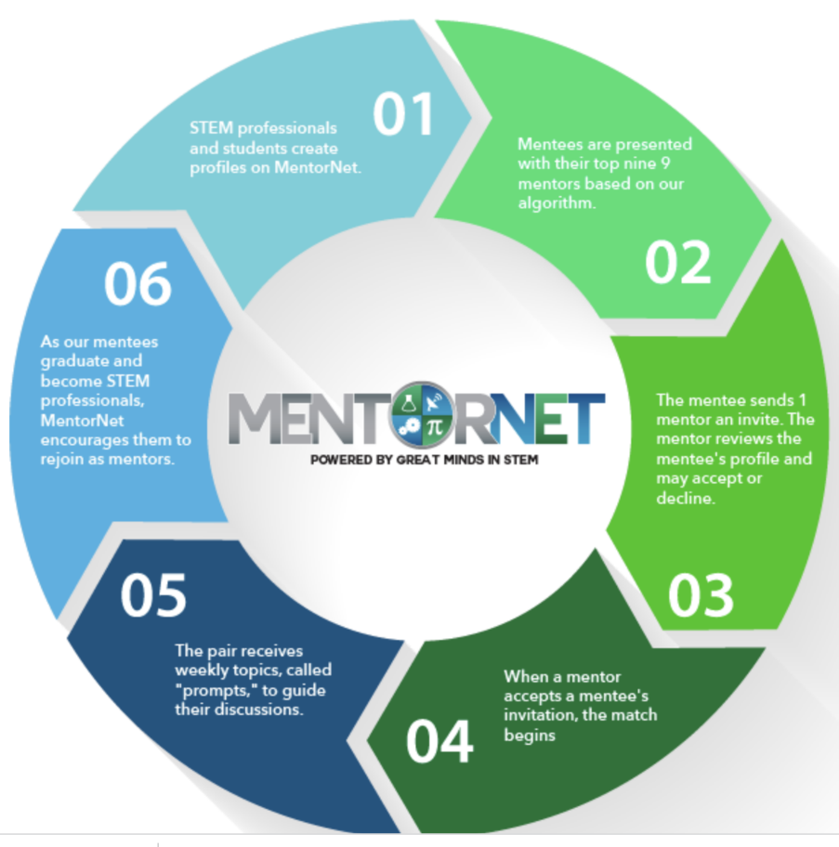
Figure 4. MentorNet mentoring cycle

3.Mentoring and e-mentoring
In the literature, mentoring is usually described as a relationship between an experienced parent - the mentor - and a less experienced young person - the mentee or guardian. The mentor supports the mentee in his/her career and professional development.
However, the concept of mentoring has evolved in recent decades. Mentoring can involve more than one mentee and one mentor. A mentor may mentor a group of mentees, and several mentors may be involved in a single mentoring programme. In addition, mentoring programmes can benefit from peer support to integrate mentoring activities. In the workplace, the mentor can also be at the same level as the mentee or even younger than the mentee (reverse mentoring).
The spread of digital technologies has opened up new opportunities for surveillance. Email, messaging tools and social networks offered new opportunities to develop mentor-mentee dialogue. E-mentoring or online mentoring is a key phase in the development of mentoring. The use of digital communication channels makes it possible to involve people in different locations in the same mentoring programme. The mentor can access online resources that integrate mentoring interventions.
The main difference between mentoring and e-mentoring is that e-mentoring changes the communication between the mentor and the mentee, and therefore their relationship. Communication and interaction in virtual space changes the perspective and even the perception of communication and interaction.
Advantages and disadvantages of e-mentoring
The main advantages of e-mentoring are:
- Easier and more extensive communication with mentors, as digital connections remove geographical and time barriers.
- Low costs in managing the mentoring programme, providing training and disseminating materials, due to the characteristics of the digital environment, such as the availability of electronic tools for sharing materials and storing and analysing interactions.
- Reducing emotional impact due to the nature of digital communication.
- Reducing the interference of ethnic, age and gender factors in asynchronous interactions.

In particular, e-mentoring facilitates communication for people with poor social skills, as digital media reduce the personality problems associated with face-to-face communication. Communication via email or messages avoids non-verbal communication breakdowns and allows time to think about responses.
E-mentoring facilitates many contacts with people in different organisations, offering virtual networking and peer mentoring opportunities. Information can be exchanged quickly, immediate feedback can be given and mentoring sessions can be planned using electronic tools, involving many participants. In addition, current conferencing platforms provide features that enhance interaction, such as the ability to share materials and exchange messages without interrupting the conversation.
However, e-mentoring also has drawbacks.
If asynchronous interaction prevents non-verbal communication breakdowns on the one hand, it weakens the expressiveness of communication on the other. However, current conferencing platforms provide features that enhance the interaction of participants, allowing them to share material and exchange messages without interrupting the speaker.
Synchronous online interaction also has some drawbacks. They require conferencing platforms, a fair internet connection and a digital device such as a computer, tablet or smartphone. Accordingly, the digital divide can be a barrier to the implementation of e-mentoring programmes, especially for economically disadvantaged people.
In addition, the use of digital conferencing platforms requires that users know how they work. During the COVID-19 pandemic, many teachers and students were challenged by a lack of knowledge about the use of remote teaching and learning platforms.
Another problem is how to ensure the confidentiality of the interaction between mentor and mentee. If these interactions are recorded, there is a possibility that they could be hacked. In the digital world, privacy must be protected from unauthorised intrusion.
Finally, the motivation to actively participate in online mentoring sessions is problematic. The mentee can turn off the camera and do other things. Loss of attention is more common in online situations involving many people. In online situations, participants do lose concentration after a certain period of time. This has been observed in teaching and learning experiences in the COVID-19 emergency (Khan, Ashraf, Seinen, Khan, & Laar, 2021). Strategies should be adopted to maintain learners' attention and motivation in online environments. They should be stimulated with questions. The mentor should avoid long and abstract speeches and use examples to argue his instructions. As in traditional mentoring, the mentor should raise the mentee's self-esteem.
Virtual professional communities can be set up to provide mentoring support. These communities should be designed in such a way that the mentor and mentee can interact both publicly and privately.
Chatbot mentoring
Advances in technology have created intelligent programmes that can simulate conversations with people. A chatbot is an intelligent program that interacts with a human using voice or text. Amazon Alexa, Google Assistant and Facebook Messenger are popular examples of chatbots.
Chatbot applications have been implemented to support students in decision-making and to provide guidance and advice. Mentoring chatbot applications could enhance traditional or e-mentoring, but cannot replace them.
Few studies have been developed to investigate the usefulness of chatbots in providing mentoring support (Wollny, Schneider, Di Mitri, Weidlich, Rittberger, & Drachsler, 2021).
It will be difficult to design a programme that simulates a complete mentoring intervention. However, in specific and limited situations, chatbots may be appropriate and useful. However, they should show emotional behaviour and befriend the mentees.
Chatbots can help connect the mentee with a human mentor whose characteristics match the mentee's needs.
Group e-mentoring
Group mentoring is a type of mentoring in which one mentor supports several mentees to form a group. Usually the mentor has specific knowledge to share with the group, which has similar needs.
In the case of group e-mentoring, the mentor supports the mentee group through digital communication channels. This allows mentors and mentees to be in different locations and interact remotely.
Peer mentoring is considered a special case of group mentoring. In peer mentoring, a group of people with different levels of competence but the same level of responsibility or career interact to build a common knowledge base through mutual support. Depending on the composition of the peer group, there are different types of mentoring. A peer group can be made up of individuals belonging to the same community, such as students. A peer group can consist of individuals from different communities who have decided to interact on the same level, e.g. adult learners with different cultural backgrounds. Professional communities are a special case of peer mentoring. Professional communities are made up of a group of people who share a common professional interest, such as a community of mathematics teachers. Online communities abound on the web, facilitated by the proliferation of social media.
You can find support for your needs by digitising your question in the question finder. The answer may be on a blog or on the organisation's website. For example, you can convert a pdf file into Microsoft Word for free. There are a huge number of sites on the web trying to meet the demand. Many of these are from software manufacturers, but many are also from users who have encountered the problem and solved it.
In this case, it is not a community of practice, but the result is essentially the same.
The wide availability of knowledge on the web also influences mentoring practices.
Group mentoring works best when the mentees have similar roles or responsibilities in the organisation or share another common learning agenda (P-Sontag, Vappie, & Wanberg, 2007).
Telepresence robots
Teleconferencing tools are now widely used for in-office communication as well as for lectures.
Recent research has focused on how to enhance teleconferencing environments with features that mimic face-to-face interaction and enhance the specific modality of remote communication, such as dashboards designed to show the progress of the interaction. Teleconferencing environments have the potential to increase interaction in the workplace. However, effective interaction needs to be designed for the specific purpose, even taking into account human factors issues.
There are a number of psychological factors that can affect learner engagement when using teleconferencing for distance learning. Recent experience in distance learning has shown that anxiety, learner satisfaction and expectations of success affect learners and trainers in a teleconferenced learning environment. Distance interaction is a new, challenging area of research. Innovative ideas need to be developed to create new effective communication environments. The introduction of telepresence robots is changing the perspective of communication and interaction in workplaces, medical centres and hospitals, as well as classrooms. A telepresence robot is a computer-, tablet- or smartphone-powered robot that enables a person to be remotely present in a specific location, enabling the robot to see what the person is looking at and hear what the person is hearing in the location (Figure 5). A telepresence robot can be stationary (fixed in a location) or mobile (freely movable).
Figure 5. Mobile telepresence robot (source: https://www.doublerobotics.com/).
Telepresence robots can be used for e-mentoring. A mentor can use a telepresence robot to move around the workplace and engage in a dialogue with one or more mentors. Using a telepresence robot, the mentor can capture the atmosphere of the workplace and see how the mentees are working (Okundaye, Quek, & Chu, 2019, June).

Bibliography
- Alston, G. D., & Hansman, C. A. (2020). Mentoring in adult and continuing education. The Handbook of Adult and Continuing Education.
- Cochran, B., Polly, P., Jones, G., & Rowe, A. (2021, July 21). eMentoring a Community of Early Career Researchers to Support and Enable Research Integrated Learning and Professional Skills Development for Undergraduate Medical Science Students. doi:10.35542/osf.io/wz7s4.
- Ensher, E. A., & Murphey S. E. (2007). E-mentorings. In: Ragins B. E. & Kram K. E. (Eds) The handbook of mentoring at work. Sage Publication Inc., pp. 299-322.
- Kaufman, M., & Hopkins, J. (2017). National Mentoring Resource Center Model Review. National Mentoring Resource Center. Available at (nationalmentoringresourcecenter.org): E-Mentoring_Model_Review.pdf.
- Khan, M. N., Ashraf, M. A., Seinen, D., Khan, K. U., & Laar, R. A. (2021). Social media for knowledge acquisition and dissemination: implications of the COVID-19 pandemic for collaborative learning-driven social media adoption. Frontiers in Psychology, 12, 648253;
- Okundaye, O., Quek, F., & Chu, S. (2019, June). Empowering remote communities: Situated distance telepresence. In Proceedings of the 18th ACM International Conference on Interaction Design and Children (pp. 494-500).
- P-Sontag, L., Vappie, K., & Wanberg, C. R. (2007). Mentoring practice. Handbook of mentoring at work: Theory, Research, and Practice. Thousand Oaks, CA: Sage, 593-616.
- Wollny, S., Schneider, J., Di Mitri, D., Weidlich, J., Rittberger, M., & Drachsler, H. (2021). Are we there yet?-A systematic literature review on chatbots in education. Frontiers in artificial intelligence, 4.

Educational kit
E-mentoring: a new qualification for continuing education and training

Module 3:
E-mentoring training and coaching support
Author(s):
prof. PB, Dr. hab. Ewa Glińska (Bialystok University of Technology)
Dr Urszula Ryciuk (Bialystok University of Technology)
Dr Ewa Rollnik-Sadowska (Bialystok University of Technology)
Dr Eng. Halina Kiryluk (Bialystok University of Technology)
Contents
 | Introduction | 32
1 | The Wheel of Life - a coaching tool for mentoring | 33
1.1. | Theory | 33
1.2. | Activities | 35
2. | The Growth Model as a tool for effective action planning | 37
2.1. | Theory | 37
2.2. | Activities | 39
3. | Dilts pyramid as a coaching method for problem solving and change in the mentoring process. | 40
3.1. | Theory | 40
3.2. | Activities | 41
4. | Support the use of coaching tools using information technology. | 42
4.1. | Theory | 42
4.2. | Activities | 44
 | Bibliography | 49

Introduction
Coaching is a process that helps to strengthen and support the coachee or the team in their efforts to change, by the coach effectively asking questions and continuously motivating and assisting the coachee towards the goal (Żukowska 2012, p. 279).
One definition of coaching describes it as "a collaborative, personalised, goal-oriented and results-driven process that promotes change through evidence-based self-learning and personal development and incorporates ethical practice" (Grant, 2006).
Mentoring is a learning relationship that involves the exchange of skills, knowledge and experience between mentor and mentee through developmental conversations, experience sharing and role modelling. This relationship can cover a wide range of contexts and is an inclusive two-way partnership for mutual learning that values differences. (European Mentoring and Coaching Council (EMCC), 2021, cited in Bęcka, 2021).
There are some similarities between mentoring and coaching (Parsloe, Leedham, 2018):
- engage in meaningful dialogue aimed at unlocking the potential of the protégé and improving their performance,
- requires confidentiality,
- requires effective supervision and management, as well as useful and appropriate processes to achieve the most positive impact for the defendant,
- use the provider's skills to ask questions, listen and give feedback,
- the service provider must have good communication skills, as well as good knowledge of organisations and learning principles,
- clear and understandable ground rules, agreements and protocols.
Both coaching and mentoring are designed to enhance employee development. Both complement traditional training methods. Their common feature is that the forms discussed are available online (e-coaching, e-mentoring) (Mróz 2013). Despite the fact that there are important differences between coaching and mentoring, there are also common parts. Mentoring uses elements of coaching, which also means that the toolset used in the coach's work is achieved (Mróz 2013).
In this chapter, the authors focus on selected tools/methods popular in coaching and point out the possibilities of using them in the mentoring process, including e-mentoring.
The tools are: the wheel of life, the GROW model and the Dilts pyramid. The chapter concludes with a description of the use of coaching tools supported by information technology.
Each subsection has a theoretical part (which looks at the characteristics of the tool/technique) and a practical part (including suggestions for tasks to be carried out in the e-mentoring process).
1. The Wheel of Life - a coaching tool for mentoring
1.1 Theory
Coaching is the art of facilitating the performance, learning and development of others (Downey, 2003). The 'Wheel of Life' is well known in coaching programmes and aims to get participants to identify areas of priority in their lives and self-assess their satisfaction with each priority (Byrne, 2005). The Wheel of Life exercise, also known as the Coaching Wheel or the Life Balance Wheel, is the most powerful and versatile tool in the coach's toolbox (Louise, 2022a). The original concept of the Life Wheel is attributed to Paul J. Meyer, who founded the Success Motivation® Institute in 1960. Paul J. Meyer was a thought leader and pioneer in the field of coaching (Louise, 2022a).
The wheel consists of 8 (up to 10) categories/areas that are important for life. Students rate their level of satisfaction with each area and then represent it on the wheel. This gives them an immediate overview of their current "life balance". The wheel of life technique gives mentors a helicopter view of how satisfied they are with their lives in key predefined categories such as health, finances and relationships (Louise, 2022a).
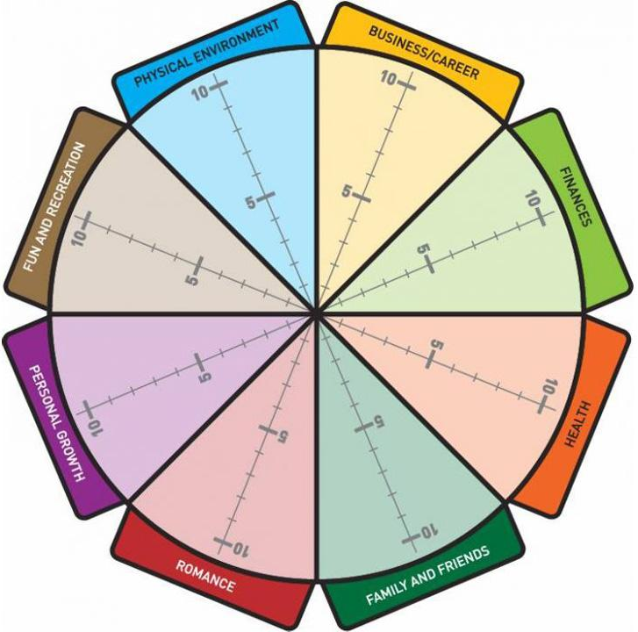
Figure 6. The wheel of life
Source : https://www.kingstowncollege.ie/coaching-tool-the-wheel-of-life

Typical life wheel categories with alternative labels (Louise, 2022b):
Family and friends: the alternatives are: community, social. Family and friends can also be divided into separate categories "Family" and "Friends".
Significant other: the alternatives are Dating, Relationship, Significant other, Life partner. Note: We've removed "Romance" from our life wheel - and here's why.
Career: Alternative terms are: profession, job, business, motherhood, fatherhood, parenthood or volunteering.
Finance: Other label ideas are: money, financial security or financial well-being.
Health: alternatives include Wellbeing and fitness. This category could also be divided into emotional health and physical health and/or include mental health.
Home environment: other terms could be simply "home", "house" or "apartment". This category could be divided into two categories - work and home environment. Finally, this life wheel category could also simply move to "Work Environment" for career or business clients.
Recreation and leisure: Some other ideas for labelling this category are: leisure, sport, recreation, play, creativity or fun.
Personal growth: the alternatives are learning, self-development or spiritual growth.
1.2. ACTIVITIES

Mentor
Identify the main areas of focus in your life (start by using the chart below).
Rate how you are doing in each area, from 1 to 10, where 10 is an excellent result and mastery achieved, and 1 means it can't get any worse.
Identify two or three actions you can take to improve in the areas where you are weakest (ideally, do the same in all areas).

Mentored by
Train your charge on what he/she has learned from the wheel.
Identify at least one activity that your mentee could work on to improve their score in one of the areas of the wheel and thus improve their life balance.
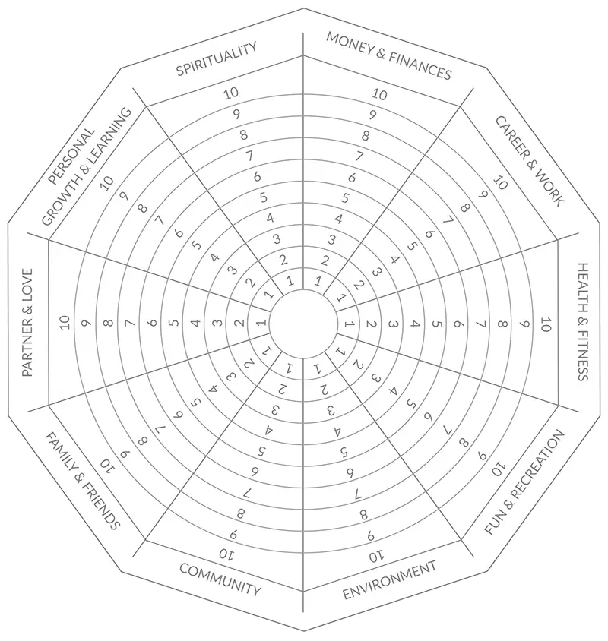
Interpretation: a fulfilling life is characterised by a sense of inner balance and growth. The more effectively you function in each of your focus areas, the more fulfilled you experience life.

Figure 7. The shape of the wheel of life
Source : https://positivepsychology.com/wheel-of-life-coaching/

2. The Growth Model as a tool for effective action planning.
2.1 Theory
The GROW model is one of the world's most popular coaching models. It is used for goal setting, effective action planning and problem solving. It is a highly effective tool for effective mentoring and coaching.
The method was developed in the late 1980s by Sir John Whitmore (1992) (a pioneer in coaching and leadership development) and his colleagues.
The GROW model consists of four main mentoring steps: G-oals, R-eality, O-ptions.
and W-ill/ W-ay Forward (Figure 8). The name of the model is an acronym of these four words.

Objective(s)

G

Reality

R

Opportunities

O

Will

W
Figure 8. Key steps in the GROW model

The GROW model is used at the start of counselling support to identify areas for support. It is necessary to follow the steps in the correct order. The first step in the mentor's work with the mentee is to set goals. It is very important that the vision of the goal is created before starting the analysis of the reality related to the goal, its feasibility and the planning of the next steps to be taken in order to achieve the goal.
The GROW model is based on relevant (powerful) questions that the mentor asks at each stage and that bring the mentee closer to the goal (Figure 9). The first three stages of the GROW model are aimed at developing the mentee's understanding, broadening his/her perspectives of reality analysis and possible vectors of action. The fourth stage is the mentee's commitment to take concrete action.

What do you want?
What is your goal?
What would you like to achieve?
What do you want to change?
What result do you want to achieve?
What would be the benefits if you achieved this goal?

Where are you now?
What is your current situation?
Have you already taken a step towards your goal?
What has contributed to your success so far?
What is your progress so far?
What's working well at the moment?

What could you do?
What are your options moving forward?
What could be your first step?
What do you think you need to do to get closer to your goal?
What are the internal/external barriers?

What will you do?
Which options will you choose to use?
What is your next step?
When will you use it?
What are you committing to?

Goals
and aspirations
Reality: the current situation
Capacities: opportunities, strengths and resources
Will: action and responsibility
Figure 9. Examples of GROW model questions
Source: own research based on: https://www.performanceconsultants.com and https://www.imperial.ac.uk/personal-tutors-guide/developing-students/coaching/the-grow-model/.

Objectives. In the initial phase of working with a defendant, it is necessary to correctly formulate the goal and create a strong vision of this goal. This stage involves identifying the protégé's main aspirations and asking him or her: What do you want? In this way, the motivation to act is developed. Goals should be specific, measurable, achievable, relevant and time-bound (SMART), as well as inspiring and challenging.
Reality. Reality analysis refers to an overview of the person's current living situation, including the identification of internal and external barriers. At this stage, the defendant seeks an answer to the question: Where are you now? This stage refers to an examination of his/her current situation, things that are happening here and now.
Opportunities. At this stage, we are looking for the greatest number of possible solutions that will allow us to achieve the defendant's objective, taking into account the available options, strengths and resources. We are looking for an answer to the question: what can you do? (This stage is about generating possible courses of action and looking for effective solutions.
Next Action (Will). In this last step, we specify actions and responsibilities. The key question at this stage is: What will you do? We prepare a concrete action plan and define the tasks and the timeframe for their implementation, as well as the responsibility of the person responsible in this area.
The GROW model is a versatile, progressive and innovative tool for developing creativity and independent thinking. The main benefits of using the GROW model are that it helps to develop skills, knowledge, experience and creativity, sharpens focus on goals, builds confidence and commitment, and increases awareness and responsibility in each area.

2.2. ACTIVITIES
Mentored by
Clearly define the main goal you consider most important to you (e.g. career development) and set a timeframe for when it will be achieved. Define how you will acknowledge that this goal has been achieved. Identify the short-term as well as the long-term benefits of achieving your goal.
Then analyse your current situation. Point out the things that have been done so far that bring you closer to your goal. Identify 2-3 main obstacles (internal and external) that are preventing you from achieving your goal.
Consider what can be done to make your goal a success. Identify three action options/opportunities that will allow you to build on your strengths and available resources. For each option, identify 2-3 advantages and limitations. Then choose the option that is most advantageous to you.
For this option, define three or four specific actions that are most important for achieving your goal. Specify the time needed to implement them and how to report on the results of your actions.

Mentor
Support your protégé by implementing the GROW model step by step. You can use illustration 3.2 and ask questions that will allow the mentee to focus on the specific goal that is most important to them and to plan the most effective and efficient way to achieve it.
3. Dilts pyramid as a coaching method for problem solving and change in the mentoring process.
3.1.Theory
The Dilts Pyramid of Logical Levels (DPLL) is one of the basic tools on which coaching is based. It is useful in the mentoring process as it supports problem solving and change management. The change that a mentor works on with a mentee occurs at many different levels and these dimensions are taken into account in the Dilts pyramid. The mentor can use the DPLL during the session to broaden the mentee's understanding.
This method was developed by Robert Dilts (1990, 1996), a trainer in Neuro-Linguistic Programming (NLP). NLP is a neuropsychological approach that postulates that there is a link between neurological processes, language and human behaviour.
The Dilts pyramid method allows you to explore a particular problem by progressively moving up the logical levels of the pyramid. This pyramid is an evolved version of Maslow's pyramid (Sandu, 2016). Using Dilts' pyramid, any situation in a person's life or in a company can be viewed from different levels. In this way, unknown needs and hidden problems can be uncovered. The pyramid is based on the concept that no problem can be solved by simply staying at the same level: to find the best solution, one has to move to a higher level. Changes at a higher level tend to have a greater impact on lower levels than vice versa (Fazel, 2013). According to this model, the same structural elements can be found in each case. By analysing these levels, it is possible to gain new insights into the situation. The Dilts pyramid has the following levels (the list starts from the lowest level and ends at the top - Dilts, 2006) - Figure 10.

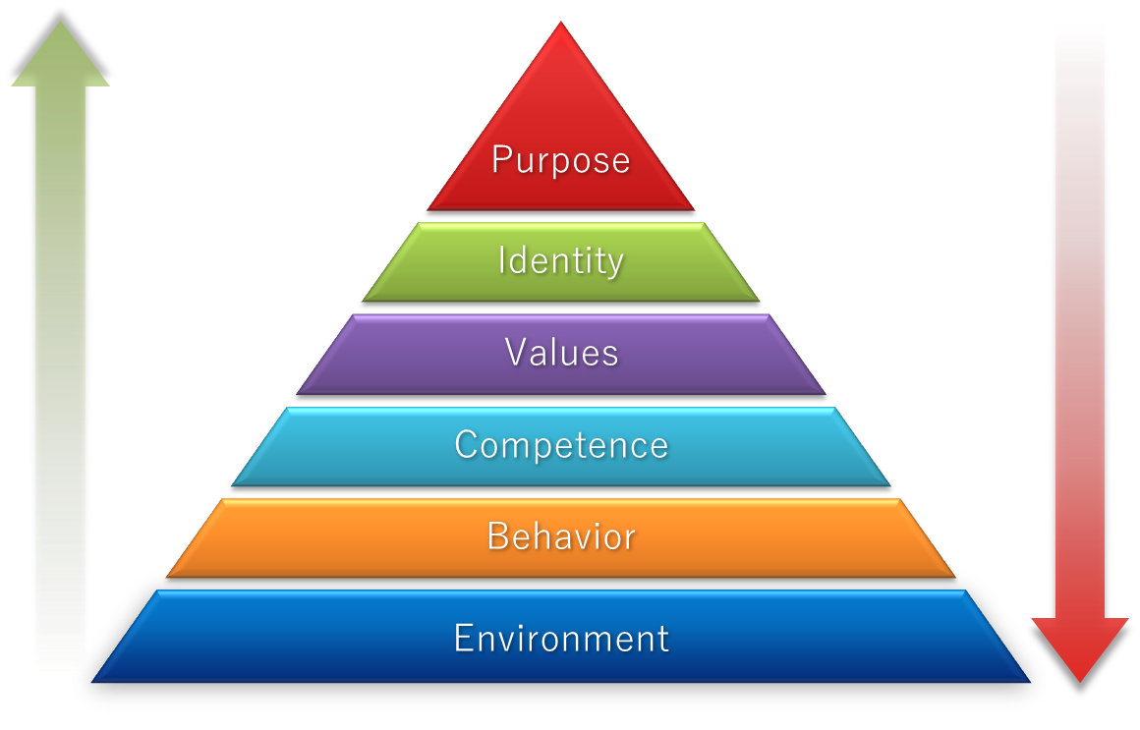
Figure 10. Dilts' logical levels of thinking
Source : https://slidehunter.com/

Video. The environment is our living conditions. Dilts' logical levels are based on the objective reality of a particular person: his living conditions and his environment. It is the answer to the questions "What?", "When?", "Where?". "By whom?", "Who owns what?". Here we see no movement. Movement is found as we move up the pyramid.
Behaviour. Individual behaviour. If the first level is our life circumstances, the second level is our reaction to those circumstances. The behavioural level is the response to the question "What am I doing?". At this level we can find information about changes and movements.
Competences. This is the level of skill and experience of an individual. The key question for this level is: "How can I influence the world? What can I do? What do I know?" At this level we can find the strategies that underpin human behaviour and answer the question "How?". At this level, knowledge is the ultimate human capital.
Values. At this level we structure our values and beliefs by answering the question: why do we think this way and why not another way? The values level answers the question "Why is this so important?".
Identity. Simply put, identity is the answer to the question "Who am I?". What group do we identify with and how do we see ourselves in the world? Individuals can clarify how they see themselves, who they are, what kind of individuals they are, how they form their relationships with others.
Objective. This is the highest level of values and meaning in life. At this strategic level, the individual answers the question "Why do I live?". Often the causes of our problems and their solutions are to be found at the lower levels.
By analysing the situation from different angles, new and more effective solutions can be found. To achieve this, you will need to know how to work with the Dilts pyramid. First of all, it is important to formulate your questions and problems correctly. Before you start working with the pyramid, you need to identify the problems you want to work on. Then you need to determine which logical level of the pyramid your problem belongs to. Then analyse the problem starting from the base of the pyramid and working your way up. Then in reverse order: from the top of the pyramid to the bottom.

3.2. ACTIVITIES
Use the six levels of reasoning developed by Robert Dilts to analyse the case below. You can use Figure 11. Mentee wants to leave her full-time job. He has been in his current job for the last five years. However, he feels that he is not fulfilling himself. He would like to start his own business. At the moment he works for others, often ten hours a day. He would like to focus on pursuing his passions and dreams and become more independent.

Purpose: Why? Purpose.

Identity: who am I?

Values: why is it so important?

Competence: how can I do this?

Behaviour: what am I doing?

Where? When? When?
Figure 11. Dilts pyramid - support issues
Source: own study.
4.Support the use of coaching tools using information technology.
4.1 Theory
In recent years, in addition to traditional face-to-face mentoring and coaching, forms based on information technology (ICT) - the internet, mobile devices (smartphone, tablet) or social networking sites - have been introduced.
E-coaching, like e-monitoring, is based on virtual contacts and the use of the internet in relationships - the conversation takes place online. Online coaching programmes were developed as a response to the time and space constraints associated with traditional coaching, reducing the problems associated with access to coaches. The online model allows the coachee to connect with the coach even when face-to-face relationships are not possible due to geographical distance or other reasons (e.g. disability, caring for a young child). By choosing e-coaching, it is possible to find a coach whose professional experience, working methodology and specialisation are closest to the needs of the coachee.
Recently, with the COVID-19 pandemic, there has been an increased need to develop e-coaching as an alternative to traditional coaching. Even meetings that used to take place traditionally have moved to virtual environments due to the demands of isolation and social distance.
Video conferencing software such as Skype, Zoom can be used in the coaching process. It is possible to connect via webcam or voice only. It is also possible to use
emails or phones, chat rooms, blogs, internet forums that offer the possibility to ask questions and get answers, podcasts that allow people to download media files or listen to MP3 files. Other tools include social networks such as Facebook and Twitter, as well as virtual worlds that allow users to interact with others without geographical restrictions.
Traditional coaching can also be supported by information technology, such as mobile apps that allow you to track your progress or expand your knowledge. However, there are also solutions that allow replacing a human avatar in the coaching process (Figure 12).
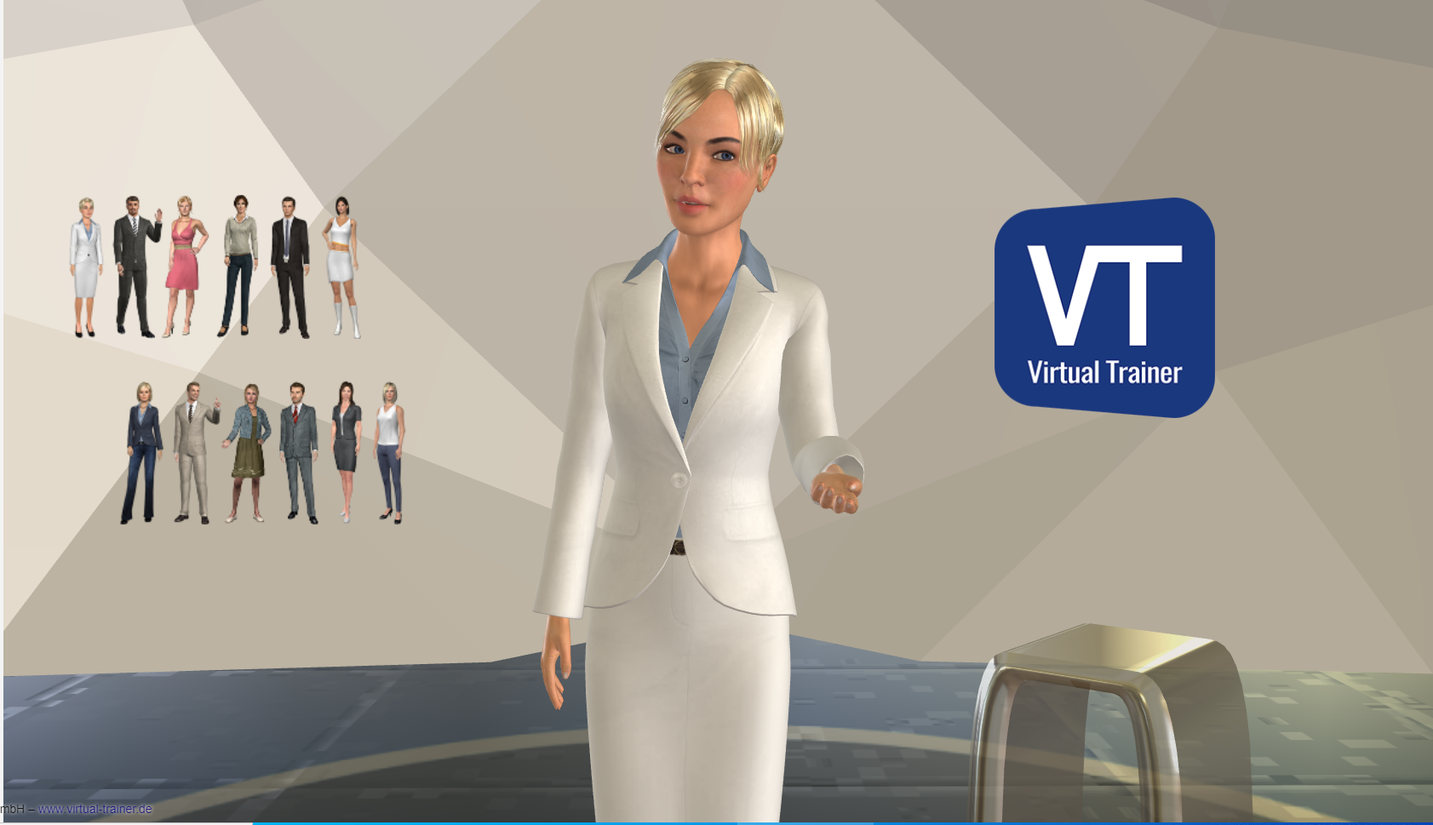
Figure 12. Demonstration of how to use Avatar
Source: Virtual Coach, https://virtual-trainer.de [2022.05.02]

The most popular types of coaching are personal coaching, life coaching, career coaching, business coaching, relationship coaching and group coaching. Regardless of the different views on the use of new media in coaching, a certain level of IT and communication competence is required for the people using them.

4.2. ACTIVITIES
Action 1
Are you interested in a topic, looking for inspiration or maybe want to become a better trainer? See if you can find the podcast that's right for you.
Castbox, iTunes, Apple Podcasts, Stitcher

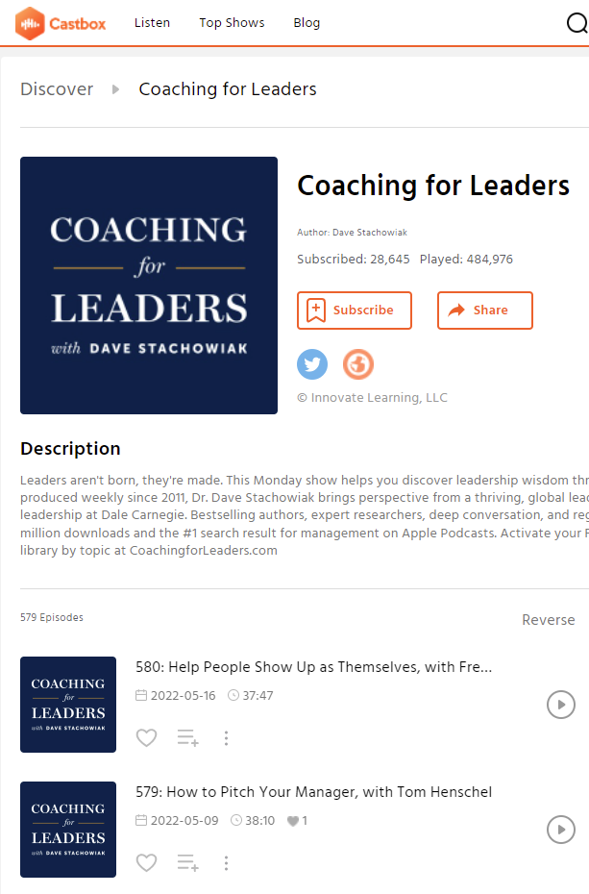
Figure 13. Examples of coaching podcasts
Source : www.castbox.fm

Action 2
Interesting popular science lectures, talks and short films from various fields, recorded at TED (Technology, Entertainment and Design) conferences around the world, are available in different languages at www.ted.com. The TED Conferences LLC application can also be used.
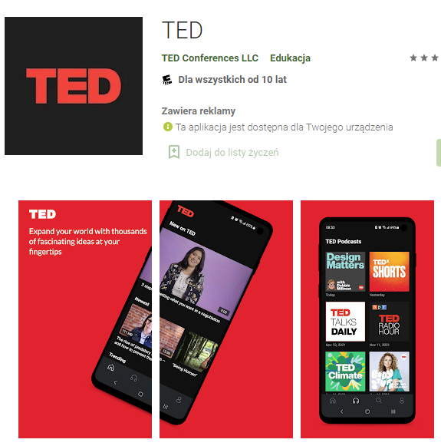
Figure 14. The TED app - an example of inspirational talks, speeches and films.
Source : https://play.google.com

Action 3
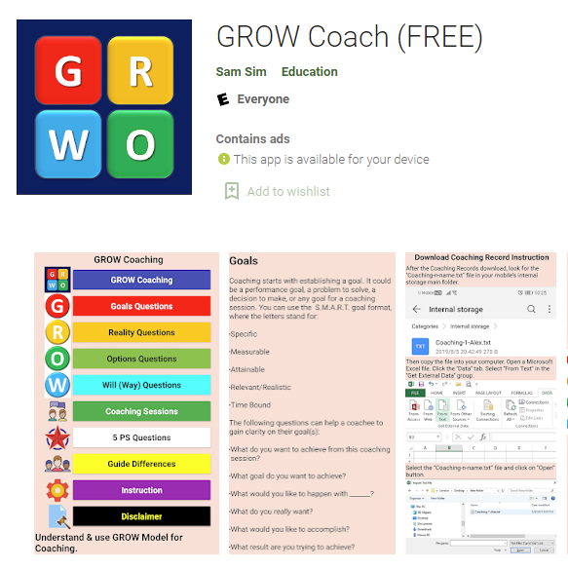
Are you a trainer and want to run an online session? Use platforms for practitioners to plan work, improve content creation and client management (e.g. NOOMII, https://www.noomii.com). You can also use traditional coaching tools to work in a modern way with the coachee. Try tools available on websites or apps that allow you to use popular coaching techniques such as the GROW model, DILTS PYRAMID or WHEEL OF LIFE. Examples of mobile apps that offer such solutions include SHIFT - Wheel of Life, Wheel of Life, Improve My Life, Diarize, Coachology Wheel of Life or GROW Coach.
Figure 15. GROW Coach application - an example of an application that uses the popular coaching technique.
Source : https://play.google.com

Action 4
There are many apps that aim to activate healthy lifestyles by helping with diet, nutrition and exercise. You need this kind of motivation - find an app that will help. The Fabulous platform was originally created to support habits, today it is a platform for self-improvement, coaching and mental health.
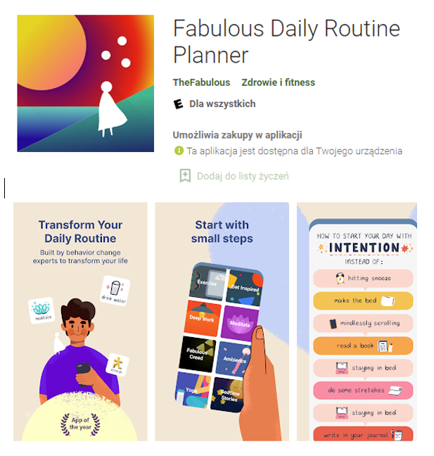
Figure 16. A fabulous daily routine planner - an example of a self-improvement app
Source: https://play.google.co m

Mentoring practice is based on the methods and techniques used in coaching. This chapter focuses not only on the description of the tools chosen, but also on the possibilities of adapting them to mentoring. The theoretical aspects are complemented by suggestions for the practical use of individual coaching methods in mentoring and e-mentoring activities.

Bibliography
- Bęcka M. (2021), Mentoring : a better understanding of the definition of mentoring, https://emccpoland.org/2021/11/08/mentoring-lepsze-rozumienie-definicji-mentoringu/.
- Byrne U. (2005). The Wheel of Life: Effective Steps for Stress Management. Business Information Review, 22(2):123-130.
- Dilts, R. (1990). Changing belief systems with NLP. Capitola, CA: Meta Publications.
- Dilts, R. (2006). From Guide to Inspirator, Polish NLP Institute, Warsaw.
- Dilts, R. (1996). Visionary leadership skills. SUA: Meta Publications.
- Downey, M. (2003). Effective coaching. Coach of coaches, Texere.
- Fazel P. (2013). The teacher-student coaching model: A vehicle to improve efficiency of adult institution, Procedia - Social and Behavioral Sciences 97, 384 - 391, DOI: 10.1016/j.sbspro.2013.10.249
- Grant, A. (2006). A personal perspective on professional coaching and professional development.
- the psychology of coaching. International Coaching Psychology Review, 1(1).

- Jeffrey S., How to Use the Life Coaching Assessment Wheel for Personal Fulfillment (includes the Business Wheel), https://scottjeffrey.com/wheel-of-life/.
- Louise E. (2022). The Complete Guide to the Wheel of Life. https://www.thecoachingtoolscompany.com/wheel-of-life-complete-guide-everything-you-need-to-know.
- Louise E. (2022). The categories of the wheel of life - for a balanced or fulfilled life. https://www.thecoachingtoolscompany.com/wheel-of-life-temnplate-categories.
- Kim M. O., Suh, R. R. (2002). Developing an e-mentoring system for office professionals, Journal of Secretarial Science, 11(1), 121-141.
- Miller K., The 17 best online coaching apps, software and tools, https://positivepsychology.com/online-coaching-software-tools [2022.05.18]
- Mróz J. (2013). Coaching and mentoring wobec współczesnych wyzwań w rozwoju darbinieku [Coaching and mentoring towards contemporary challenges in employee development], Nauki o Zarządzaniu, 3 (16).
- Parsloe E., Leedham M. (2018). Coaching and mentoring. Strategies. Tactics. Techniques, PWN Scientific Publishing House.
- Performance Consultants, https://www.performanceconsultants.com/
- Rowland K. N. (2012), E-Mentoring: An Innovative Twist to Traditional Mentoring, Journal of Technology Management & Innovation, 7(1), 228-237.
- Sandu A. (2016). The use of the pyramid of neurological levels in the management of human resources motivation, Revista Romaneasca pentru Educatie Multidimensionala VIII(2), 31-44, DOI:10.18662/rrem/2016.0802.03.
- Singh V., Bains D., Vinnicombe S. (2002). Informal Mentoring as an Organisational Resource, Long Range Planning, 35(4),389-405.
- Straus S.E., Johnson M.O., Marquez C., Feldman M.D. (2013). Characteristics of successful and unsuccessful mentoring relationships: a qualitative study in two academic health centers, Academic medicine, 88(1), 82-89.
- Tolmacheva D., The 7 best wheel of life apps for Android, https://androidappsforme.com/wheel-of-life-apps-android [2022.05.08]
- Virtual Coach, https://virtual-trainer.de [2022.05.02]
- Warner, T. (2012). E-coaching systems: Convenient, anytime, anywhere and inhumane. Performance Improvement, 51, 22-28.
- Whitmore, J. (1992). Coaching for Performance. GROWing People, Performance and Purpose.
- Żukowska J. (2012). Naukowe ujęcie coachingu, [in:] P. Wachowiak (2012). Man in the organisation. Teoria i praktika, Oficyna Wydawnicza SGH, Warsaw.
- https://leadersheep.com.pl/blog/model-grow-sztuka-zadawania-pytan-w-coachingu
- https://www.imperial.ac.uk/personal-tutors-guide/developing-students/coaching/the-grow-model/
- http://www.educoaching.pl/2011/06/model-grow-struktura-sesji-coachingowej.html

Educational kit
E-mentoring: a new qualification for continuing education and training
Module 4:
Online individual interaction, Virtual teams
Author(s):
Ingrīda Veipa (Jēkabpils Agribusiness College)
 | Introduction | 52
1. | Communication in e-environments, virtual collaboration | 52
2 | Virtual teams or e-groups | 53
3. | Leadership skills in the e-environment | 54
4. | Video communication tools for distance learning. | 56
5. | Manage your team remotely | 58
6. | Characteristics of a digitally competent educational institution | 59
7. | Criteria for assessing a digitally competent educational institution | 60
8. | Using the Skolo.lv platform to organise learning | 63
 | Bibliography | 65
Marika Boķe (Jēkabpils Agribusiness College)
Contents

IEVADS
Mentoring is a process in which a person serves as a mentor who encourages and helps another to develop (Gay, 1995).
A relationship between a less experienced person and a more experienced person, known as a mentor, through which the mentor facilitates and supports learning. This can be an individual relationship or a network of several mentors. This network may include colleagues, colleagues 'ahead of the ladder' or supervisors. Psychosocial mentoring includes mentoring roles such as counsellor or friend, while career-related mentoring includes mentoring roles such as coach or sponsor. Each mentoring structure may be better suited to support specific mentoring functions or desired outcomes. For example, a peer mentoring structure may support psychosocial functions, while supervisory mentoring may support career functions.
Mentoring is a more structured, sustained relationship to support professionals at an early stage in their career, at a career transition or when they face particular challenges. For example, newly qualified teachers, teachers working with new teachers, supply and returning teachers, or recently appointed headteachers can benefit from mentoring. A mentor is usually a more experienced colleague who is familiar with the other person's needs and professional context. The process is usually time-limited and focuses on developing the teaching skills and classroom practice of the less experienced colleague. Mentoring is most effective when mentors are selected for their knowledge and experience and are provided with training in mentoring skills, adult learning and the ability to identify and disseminate best practice.
Mentoring, by its very nature, assures young people that there is someone who cares about them, reassures them that they are not alone in dealing with everyday problems and makes them feel important. Research confirms that quality mentoring relationships have a strong positive impact on young people in a variety of personal, academic and professional situations. Ultimately, mentoring provides the young person with personal growth and development, as well as social and economic opportunities. However, not every young person receives mentoring support.
The Covid 19 pandemic highlighted the need to develop e-mentoring. Remote communication also became increasingly important among businesses, as all sectors moved from face-to-face to remote communication.
- Communication in e-environments, virtual collaboration
Communication in the e-environment takes different forms to face-to-face communication. For some it is easy to find a language, for others communication is difficult. However, it is easier for people to communicate in an e-environment because there is no direct contact, people do not see each other, so body language, which complements verbal communication, cannot be observed.
Virtual collaboration is a form of collaboration between e-group members using oral, visual, written and digital media.
Virtual collaboration uses a variety of communication channels for correspondence, calls, video conferences: social networks, emails, Whatsapp, Google Meet, Zoom, Microsoft Teams, Skype. More effective channels are those that offer online collaboration tools, allow sharing of materials and editing of existing files.
Virtual collaboration is faster if you can provide a way of communicating that is similar to face-to-face interaction between team members. However, technological limitations prevent virtual collaboration from being as effective as face-to-face communication. Team members working remotely usually communicate by phone or other technologies. As this type of communication does not involve body language and immediate reactions, it can lead to different interpretations and misunderstandings.
If participants have met in person, it will be much easier for them to build relationships in the e-environment because they know each other. For participants meeting for the first time in a virtual environment, the organisation's guidelines explaining how to use the technical tools and how to communicate would make it easier. New participants should be familiarised with the specificities of the work tasks, for example, access to document production procedures, registers and access to databases.
The complexity of communicating in an e-environment is that you have to be careful about the protection of personal data.
A quality work result is based on agreement on what is the responsibility of one party and what is the responsibility of the other, a genuine concern for achieving the overall result, and support during the work, asking from time to time how things are going, whether it will be possible to meet deadlines, what support is needed.
Several studies have shown that face-to-face meetings are more effective than digital communication, so virtual teams should also be given the opportunity to meet face-to-face where possible, thus strengthening collaboration.
It is advisable to have communication specialists who encourage working group leaders to use new digital tools or improve existing ones. Young people like to use tools such as Kahoot, Mentimeter for quick feedback in the learning process.
- Virtual teams or e-groups
Any working group, whether face-to-face or remote, needs a leader, or a facilitator if it is a different type of group. Of course, groups can be set up without leaders, but then there will be difficulties in allocating responsibilities and tasks. If the group has a leader, he or she will not only be able to allocate tasks and responsibilities, but also to monitor progress.
Teams are more often formed between people who know each other, so it's easy to form a group. During the learning process, a group can be formed by the trainer without taking into account the personal acquaintance of the group members. A currently popular form of competition for new business ideas is hackathons, in which teams were formed in an e-environment of the business/idea of their choice.
During the Covid 19 pandemic, communication with other colleagues and lecturers was done remotely. The main platforms used were Zoom and Microsoft Teams. Socrative is a tool for creating, searching, distributing and running tests. Among its advantages, it is worth noting the ease of development and the pleasant appearance.
A virtual community, e-community, online community is a group of people who primarily use computer network technologies to communicate (Kasyanov, 2018).
- Leadership skills in the e-environment
An effective e-leader is one who brings group members together through an appropriate communication medium to achieve group goals, communicates goals and objectives and connects all group members using knowledge and experience to manage conflicts and complexities.
E-leaders are people who are able to foster successful innovation and benefit from advances in information and communication technologies. An e-leader has skills such as e-environmental knowledge, communication skills and leadership skills. An eLeader not only takes the lead, but also shapes the overall team spirit, helps resolve conflicts, helps integrate new tools into the work process, monitors the achievement of objectives and manages tasks.
One of the most important management skills in the e-environment - work planning - is harder to implement. It is important to understand that an effective manager manages not only a team of people, but also machines and technology. It is important that people know that you are part of the team and that you are available if they need help. A leader needs to be able to build strong bonds between team members, and this is harder to do in an e-environment. The leader needs to establish channels for information transfer between team members.
E-management is about developing certain capabilities to improve the way an organisation operates in a virtual working environment. For e-leaders, certain social skills may not be sufficient to lead in a virtual environment, where these qualities need to be complemented by the skills to manage different virtual communication platforms. Dulebohn, J. H., & Hoch, J. E. (2017) highlighted the need for new theory and empirical research to help organisations design, structure and manage virtual teams.
Working in virtual teams has become increasingly common in some sectors, especially after the Kovid 19 pandemic. To address fast-growing markets, companies are making changes to management structures, work systems and technology deployment. HRD and virtual HRD practitioners and researchers should draw on good practice examples from previous research on virtual teams. Shared leadership is one of the emerging approaches that shows promise in solving complex problems, as it responds to problems by drawing on the knowledge of all participants (Soo Jeoung Han, 2022).
E-leadership refers to leadership in a new era, the information age, characterised by rapid technological development, a global economy in which companies are constantly moving across borders where they can make a profit. Leadership is needed to solve many of the challenges posed by the information age.
E-Leadership is vital for companies and industry to excel in their business. E-Leadership is the key to leveraging new digital technologies for innovation and transformation, managed in the right organisational context and embedded in the business strategy. E-Leadership skills are the skills required for an individual to initiate and implement digital innovation:
- Strategic management: to lead multidisciplinary staff and influence stakeholders across boundaries (functional, geographical).
- Business agility: innovative business and operating models that deliver value to organisations.
- Digital agility: anticipating and driving change to improve business performance, using digital technology trends as innovation opportunities (Wang, 2009).

Figure 17 E-Leadership Skills Triangle

E-leaders are people who are able to foster successful innovation and benefit from advances in information and communication technologies. Ensuring sufficient e-leadership skills in the economy is seen as contributing to economic growth and job creation, as it plays a key role in identifying and exploiting opportunities for innovation. E-leadership skills include competences that enable an individual to initiate and lead ICT-related innovation at all levels of an enterprise, starting from its inception.
Virtual team members are usually separated by distance and are much more influenced by cultural, geographical and linguistic factors. To work effectively, virtual teams need competent leaders who can establish clear team principles and support positive group dynamics.
- Video communication tools for distance learning.
The Kovid-19 pandemic brought its own adjustments to the lives of people around the world, including in Latvia, when work and study had to be planned remotely. This created the need for various online tools.
The authors investigated the most commonly used video communication tools for distance learning.

Table 3
Comparison of video communication tools

Name | Description (options) | Group formation | References
MS Teams | MS Teams is beneficial if you use Microsoft and have purchased a licence. You can also use the free version. Here you can create groups, plan in an online calendar, share your screen, add files, assign tasks, use the whiteboard. Lessons can be recorded. | Groups can be formed | Feedback can be given by typing in the chat room, by turning on the microphone and video camera and replying, by sharing documents and completing them together or individually, and is visible to all connected participants.
Enlarge | A Zoom account is required to host a Zoom meeting.  With online classes, there are fewer options. In the free version, you can use 40 minutes, after which the meeting is cancelled and the number of participants is limited to 100. Sessions can be recorded. No calendar. And to be invited to participate, each participant has to send a link. | The breakout room option allows participants in an online meeting to be divided into separate virtual rooms where they can work separately from others. You can set a time and when it expires, your participation in the small group is cancelled. The online facilitator can also move from one group to another and work | Feedback can be given by typing in the chat room, turning on the microphone and video camera and replying.
Google Meet | Anyone with a Google account can create an online meeting with up to 100 participants and speak for up to 60 minutes per meeting. Live subtitled meeting (in English), screen sharing with participants. | There is no information on whether you can create groups and work. | Messaging to participants, integration with Google and Microsoft Office apps (Microsoft Office users can also be added to the invitation).

In the comparison, the authors find that MS Teams is more usable in the learning process, and if the educational institution uses Office365, it is also possible to share files and work both together and separately, thus getting feedback.
- Manage your team remotely
When organising learning processes remotely, you need to think about setting up effective working teams and consultancy. Effective team management in an e-environment requires technical solutions (computers, projectors, internet, etc.). The classic e-mail is one of the management tools, but it is more useful for correspondence. In a business environment, a CRM platform can be considered as a management tool. The advantage of these platforms is that the manager can not only manage work groups but also follow the whole work process. One of the effective group work tools that can be used to enable a group to follow processes together is the Miro platform.
The team can be managed remotely using a variety of tools such as the most commonly used platforms Zoom, Google Meet, Microsoft Teams, etc., which allow real-time conferencing.
Messengers are also a management tool where you can create groups or communicate privately, e.g. Whatsapp, Viber, Telegram. These communication platforms can also easily be used to maintain informal relationships, which is no less important to motivate young people to achieve the objectives of the working group. Informal communication is also important, which involves getting to know the group members, their hobbies, interests and talents.
On the one hand, remote management of teams requires stricter control procedures, as without face-to-face meetings all tasks can be left to the last minute. At the same time, it is necessary to choose the information technologies and tools that best allow young people to feel independent and to be aware of their responsibility to complete their work independently within the deadlines (self-management). It is important to build trusting relationships within the team.
If it is not possible to meet the team members directly, platforms that offer an informal setting to play the game should be used to bring the team together. Rapid information exchange and effective communication channels should be ensured. If the team project is implemented in phases, deadlines for the submission of information should be mutually agreed. The format and standards for submission of information should be defined within the team, as each member may have a different opinion on how much information is sufficient and what information is needed at all. Ethical and communication standards within organisations should be taken into account.
In addition to the content of the communication, you need to know what means and channels are available to young people. Some people may be more comfortable working on a mobile phone, so make sure all apps and platforms are supported on mobile devices. Internet accessibility and speed is also an important factor when choosing methods and platforms for team communication. It is most convenient to find out by conducting small surveys and in some cases it is useful to conduct anonymous surveys to get the reality of the situation.
WhatsApp is a popular tool for young people and teachers to communicate with each other. It can be used to maintain a "team spirit" by regularly inviting people to engage in an exchange of views, by creating messages in the form of poll questions that encourage participants to respond and share additional experiences and/or photos on a given topic. It is important to define the specific problem and ensure that those involved have the opportunity to work as a team (suggest which tools to use, what format to present their solution in, etc.).
When communicating with your teammates, it's important to find an individual approach for each of them.
With very simple questions such as "How did you do on the assignment?", "Which source of information gave you the most insight into the problem?".
This way, participants can regularly talk about their feelings, challenges, successes and failures when working remotely.
When working remotely, it is important to be able to get feedback, for example by sharing a computer screen, so that you can see at a glance how a task is progressing and can suggest improvements. You should choose digital tools that allow screen sharing and allow several people to work on a document at the same time.
MURAL connects teams to a digital whiteboard, Jamboard is a digital whiteboard that allows real-time collaboration via a Jamboard device (55-inch digital whiteboard running G Suite services), web browser or mobile app. Canvanizer is a web-based tool that helps to define strategy using pre-structured canvas templates.
- Characteristics of a digitally competent educational institution
In Latvia, the National Centre for Education is implementing the European Social Fund project "Competences-based approach to curriculum" from June 2021. Skola2030 has launched a professional competence development course for teachers "The role of an educational technology mentor for targeted use of technology in education". This training is planned for teachers who will act as methodological adult educators in order to integrate educational technologies in the learning process in a targeted way. This role is planned to be defined at the level of each educational institution, including pre-schools, as well as at the level of the municipality.
The aim of the project "Competence Approach to Curriculum" (Skola2030) implemented by the National Centre for Education (NCES) is to develop, validate and sequentially implement in Latvia a general education curriculum and approach to teaching from pre-school to secondary school that will result in students acquiring the knowledge, skills and attitudes necessary for life.
The project includes the review and improvement of existing curriculum documents, the development and validation of updated curricula, the development of subject curricula and teaching materials, including for children with special needs or disabilities.
The author of the article M. Boķe uses the opportunity to train as an educational technology mentor to help educators in the educational institution where she works to learn various digital tools, to get information, to search and test various information technologies in the field of education, to help educators in the process of digitisation of the educational institution.
M. Boķe assessed whether the educational institution is digitally competent during the training. The assessment used criteria and three colours. Green was used for points that are already being implemented in the school and red for those that pose the biggest challenges. Factors that are partially implemented can be highlighted in yellow. It is then necessary to assess which colour predominates in the following criteria. Factors that are not implemented in the school (red) are assessed as to whether they need to be developed or whether they are relevant for the educational institution.
- Criteria for assessing a digitally competent educational institution
- The administration and management of the institution:
- A vision for the use of digital technologies is in place.
- A long-term action plan for digital technology and innovation is in place.
- A long-term action plan for the development of digital technology infrastructure is in place.
- A long-term action plan for using digital technologies to improve learning and make the school more effective as a learning organisation has been developed.
- Teachers' digital skills are assessed.
- What is needed to improve teachers' digital skills and how to implement it.
- Cooperation with external partners is being developed to introduce digital technologies and innovations.
- Creating an environment for digital innovation.
- Data is used in a targeted way to improve educational management, learning, collaboration and decision-making.
- There is a clear system in place for using data collected at school to evaluate teachers' performance.
- The school has specific people responsible for planning, implementing and supporting digital technologies.
- School staff are provided with professional support and professional development opportunities in the use of technology and process optimisation.
- Opportunities to automate and streamline school processes using technology have been explored.
- The school assesses staff motivation and job satisfaction using technology, and has an appropriate human resources management strategy and planning.
- The school plans a budget for digitalisation - training staff and automating processes.
- Environment and infrastructure
- Wireless network coverage is available.
- Children and young people have access to digital devices outside school hours.
- Various digital devices (interactive whiteboards, projectors, TVs, etc.) are available for demonstrations.
- A single cloud/datastore system is in place.
- A common email address system is in place throughout the school.
- Full use is made of electronic journal systems (e-class, mykoob, etc.).
- The latest innovations in digital technology (3D printers, 3D scanners, CNC, etc.) are available.
- A system for the use of personal digital devices (BYOD) has been introduced.
- Technical support is available for infrastructure maintenance and equipment use.
- The physical learning environment is adapted to learning with technology.
- Technology is used to support the learning needs of pupils with learning disabilities.
- Learning platforms (MS Teams, Google Classroom, etc.) are used, and teachers and students are provided with instructions and support on how to use them.
- Communication and cooperation
- The Authority's website is regularly updated and up-to-date information is published.
- Social networks are used to communicate with the public.
- A single image and digital identity for the institution is in place.
- Electronic platforms and various digital tools are used for parent and community surveys and data collection.
- Digital tools are used effectively to communicate with parents/community.
- A calendar of the institution's activities, tests/essential learning activities is published and available.
- Information on the progress and dynamics of children and young people is published (followed by parents).
- Digital technologies are used to educate parents and society. (Video lecture, etc.)
- Clear processes for digital communication with parents and how learning outcomes, needs and support are communicated.
- Parents can get support to improve their digital skills.
- The communication process takes into account feedback from parents and the public on the institution's communication practices.
- Teacher community
- There are common requirements and rules for the use of digital technologies.
- Teachers can assess their digital skills and get support to improve them.
- Digital technologies are used to foster cooperation.
- Distance learning is used for professional development.
- Teachers learn together how to use digital tools and technologies in their daily work.
- A database is being created to store and share (preserve) digital material.
- Exchanging and learning from each other good practices in the use of digital technologies in learning situations.
- Participation in digital technology projects is encouraged.
- Teachers are involved in the eTwinning platform and projects.
- Teachers engage in networks and use wider teacher collaboration platforms to build partnerships outside school.
- Teachers have a clear professional development plan and can be supported to use technology in their teaching.
- There is a common approach and criteria for evaluation using digital technologies.
- Support is provided for data processing and analysis, and teachers have a clear framework for using data to improve teaching and learning.
- Collaborative and peer learning groups/communities are set up where teachers from the institution share experiences, examples and practices.
- You can observe the teaching/learning process and learn how to use technology from good practical examples.
- Together, they discuss how technology can help support learning, especially for pupils with learning difficulties, and how it can be implemented in practice.
- Teaching assistants/IT support can be used to help the teacher organise the lesson during the teaching process.
- Learning in everyday life
- There are common requirements and rules for using digital technologies.
- There are common criteria for the digital submission of student work (presentations, written work, SRWs, projects, etc.).
- The importance of using digital technologies in learning is obvious.
- Understanding internet security and digital identity, copyright is created.
- Digital technologies can be used in a targeted, meaningful and planned way in a variety of learning areas.
- Digital technologies can be used to meet individual learning needs and support.
- There is an opportunity to get involved in the digital identity of your school.
- You can learn about the latest digital technologies and innovations.
- There is an opportunity to create new/innovative digital solutions (educational products).
- You can assess your digital skills and get support to improve them.
- Regular feedback on the learning process and the support received.
- Support is available to improve digital skills.
- There is a structure in place for using school learning systems to store/use data and learning outcomes.
- There is also the possibility to use technology to complete the exercise tasks.
- Technology can be used to give and receive feedback.
- There is the possibility to use technology as part of a self-directed learning process.
- There are clear criteria for how project work should be designed, documented and evaluated.
- There are opportunities to learn about the technologies and digital tools used in different areas of learning, relevant to the context of the field.
There is no methodology for this assessment to determine how digitally competent an educational institution is.
- Using the Skolo.lv platform to organise the learning process.
Skolo.lv is a free virtual learning environment for teachers and students to plan and manage lessons, both face-to-face and remotely, and to implement blended learning.
Skolo.lv is a learning platform that will be available free of charge to all Latvian general education institutions (schools and preschools) from autumn 2021.
The learning platform aims to enable educational institutions - both general and vocational - to use digital technologies in education. The learning platform is based on the open source learning management system Moodle and is available free of charge for students and teachers to enhance learning and teaching, both face-to-face and remotely.
From August 2022, all Latvian educational institutions have the opportunity to start using the MS Teams communication and collaboration platform, which includes a Microsoft licence, together with skolo.lv free of charge, thus strengthening the daily multilateral communication between a teacher and a student or group of students.
The Skolo.lv environment can be used for:
  - Teachers:
- Create content - create your own structured, sequenced, scalable set of digital learning tools and activities in the form of an e-course for everyday learning, including explanations, demonstrations (written, audio or video) in different formats on a specific topic;
- Use e-course templates;
- Interactive learning approach;
- Differentiate teaching;
- Evaluate performance;
- monitor your progress.
2. Pupils:
- Access to learning content - access to structured and transparent learning content, created by the teacher or Skola2030 as an e-course, both for learning new content and for revision and reinforcement;
- Complete the tasks;
- Share and collaborate;
- Get feedback;
- Create a portfolio.
System support for registered users
- Video tutorials
Users of the learning platform have access to video tutorials for skolo.lv, which are published on the skolo.lv YouTube channel.
- User forum
skolo.lv users have access to a virtual user experience community or forum, where they can address their questions by communicating with other users of the learning platform.
- Consultations and introductory workshops
Individual consultations and introductory seminars on using skolo.lv are organised for teachers in educational institutions.
- Online support centre
Users have access to an online support centre at any time, where they can find helpful instructions and solve any unclear issues to make their work with skolo.lv easier.
You can download and use the materials in your daily work.
In this environment you can organise tests, add videos. Set time limits for materials, add participants. Latvian teachers use this environment in their teaching and as teachers use materials created by other authors. It is a good support for new teachers or teachers who have not done remote learning before. It is planned to use this environment in schools, training teachers on the advantages of this environment, as it can organise a combined learning process, as it is defined that distance learning should be implemented in schools in parallel with face-to-face learning.
Bibliography
- http://www.ibe.unesco.org/en/glossary-curriculum-terminology/m/mentoring
- https://www.nmu.edu/Webb/ArchivedHTML/UPCED/mentoring/docs/Role-mentor.pdf
- https://www.forbes.com/sites/theyec/2022/07/11/3-ways-to-successfully-manage-a-fully-remote-team/
- https://www.linkedin.com/pulse/5-essential-leadership-skills-required-lead-virtual-teams-turner
- https://www.pwc.com/us/en/services/consulting/business-transformation/library/covid-19-us-remote-work-survey.html
- https://www.eurofound.europa.eu/observatories/emcc/comparative-information/emerging-forms-of-entrepreneurship
- https://www.gemconsortium.org/reports/latest-global-report
- https://metodes.lv/mentorings/kas-ir-mentorings
- https://www.mk.gov.lv/lv/media/5408/download
- https://www.catalystteambuilding.lv/raksti/blog/blog-virtualteams-ed
- https://studme.org/220783/sotsiologiya/sotsiologiya_interneta
- https://www.dal.ca/sites/celnet/about/eleadership.html
- https://www.igi-global.com/dictionary/traditional-leadership-light-hrms/8782
- https://biznesam.swedbank.lv/ievads/izaugsme/attalinata-komandas-vadisana-53002
- https://journals.sagepub.com/doi/10.1177/15344843221093376
- https://www.frontiersin.org/articles/10.3389/fpsyg.2020.590271/full
- https://apps.google.com/intl/lv/intl/lv_ALL/meet/how-it-works/
- e-Leadership_Digital_Skills_for_SMEs.pdf (eufordigital.eu)
- https://ugunsskola.lv/zoom-meeting-instrukcija/#1585910886673-0332a122-00c7
- https://skolo.lv/mod/page/view.php?id=11855363
- www.skolo.lv
Educational kit

E-mentoring: a new qualification for continuing education and training
Module 5:
E-mentoring software

Author(s):
Stavriana Yiorka (A&A Emphasys Interactive Solutions)
Assoc.Prof. PhD Veselina Jecheva, (Burgas Free Univeristy)
Professor, PhD Krasimira Mineva (Burgas Free Univeristy)

Contents
 | Introduction | 67
1. | Videoconferencing platforms | 67
2 | Interactive lessons and brainstorming tools | 71
3. | Assessment tools | 76
 | Bibliography | 79

Introduction
As technology has evolved, developers have created a number of online communication tools that allow information to flow during the mentoring process when face-to-face (F2F) communication is not possible. Communication platforms are one of the most useful inventions, especially in the event of a pandemic, as they allow companies and organisations to integrate real-time communication and strengthen electronic mentoring, also known as e-mentoring (Brosix, 2020).
In fact, the true definition of a communication platform is a software solution that facilitates the sending of external and internal messages. This software, in turn, works in a variety of ways, including channel, telephony, videoconferencing, task management and team messaging. In particular, videoconferencing can replace face-to-face meetings, workshops and events, which are not always beneficial for the mentors and mentees involved, but fulfil the objectives of the meeting.
With the right video call technology, you can organise meetings with mentors and mentees, give product presentations and organise webinars. Video conferencing platforms offer not only live video, but also many additional features. Participants can connect from any device (phone or computer), listen to audio and provide feedback in a group chat. Overall, these platforms can help and improve meetings (LumaApps, 2022).
Using communication platforms, mentors can take various actions, such as checking in with mentees, morphing themselves to reduce distractions, recording the meeting to remember what was said, etc. Internal communication is not the only advantage that video meetings can provide. If an online mentoring session is organised, use cloud computing to save time later by remembering key elements (Pickell, 2022).
- Videoconferencing platforms
2.1 Microsoft Teams:
Microsoft Teams (MS) is designed to help you work more efficiently and collaborate more effectively. The interactive aspects of this platform are built by combining several Office applications, such as Word and SharePoint, with its design and infrastructure. In addition, Microsoft was able to incorporate Skype for Business into the Microsoft Teams app. This application was ultimately developed as a reaction to the rapidly growing number of collaboration tools such as Slack, which have managed to dominate the industry in recent years (Microsoft Teams, 2022).
Overall, Microsoft Teams is a tool with several features, such as the ability to instantly start a videoconference from a chat, making it a multi-purpose tool that is not just for the workplace. One of the most creative features of Microsoft Teams is the ability for users to invite guests who are not members of their company's Azure Active Directory. In addition, on Android and iOS, the Microsoft Teams mobile app facilitates voicemail (Boudinet, 2020).
All Microsoft Teams plans include:
- Web versions of Word, Excel and PowerPoint;
- Storing and sharing files;
- Up to 300 users can be accommodated at the same time;
- 24/7 phone and web support.
However, the features included in each Microsoft Teams account vary depending on the payment plan you choose. Click on the following link to see the payment methods!
Microsoft Teams are a great e-mentoring opportunity because:
a. Microsoft Teams is an all-in-one tool with a set of features that help improve productivity. For example, there is a Teams chat feature called Loop Components that allows you to create lists of action items for a meeting in a chat window while you are in the meeting. You can add due dates and trigger notifications to relevant people in the Team Chat window so that everyone involved can see the progress of tasks. b
. Its free version offers a good package that can bring many people into one digital classroom. c
.
Microsoft Teams simplifies collaboration and classroom management for e-mentors as it
allows internal meetings, sharing of materials and lesson plans, rubrics, reports, assignments and steam-lecture preparation. d.
Microsoft Teams can truck through insights and thus offers personalised learning to take action and improve results. e.
It offers several accessibility features (e.g.
translations, live captions, immersive reader) that make it an inclusive tool for all mentees or mentors.

Azure Active Directory (Azure AD): a Microsoft cloud-based identity and access management service that helps employees sign in and access resources.

Additional resources on how to navigate Microsoft Teams and use video conferencing.

To find out more, watch this video: https://www.youtube.com/watch?v=SY46T5kgZVQ

  - Google Meet:
Google Meet (Google Hangouts) is part of Google's productivity suite, G Suite. Customers can integrate Google Meet with other products in the Google suite, including Gmail and Google Calendar. This allows you to set up Google Calendar so that Google Meet links and phone numbers are automatically created. The speaker's video stream is automatically recognised and displayed in Meet, but a gallery view is also available (Brosix, 2022).
Google has managed to improve the platform's sound and video quality, as well as its noise reduction capabilities. These features ensured that they will continue to be seen as market competitors. The meeting can last up to 60 minutes and is open to anyone with a free Google account. Premium paid options are available for businesses, schools and other groups, which include live streaming for up to 100 000 viewers per domain (Boudinet, 2020).
Zoom is a great e-mentoring opportunity because:
a. It makes it easier and more efficient to organise and plan an online meeting with a mentee or mentor group, as it includes many other features and apps such as Google Calendar, Gmail, etc.
b. Meet can enable you to enrich your teaching and learning with advanced features such as breakout rooms, live streaming, attendance tracking, Q&A, polls and more if you register for Teaching and Learning Upgrade or Education Plus. c
. It has a simple and user-friendly interface that will make it easier for mentors and mentees to navigate.

Additional resources: https://apps.google.com/intl/en/meet/how-it-works/

To find out more, watch this video: https://www.youtube.com/watch?v=wGXI0KpkR50

  - Increase:
Zoom has become one of the most popular communication platforms specialising in video conferencing and is widely recognised as one of the most consistent meeting platforms. You can integrate Zoom with any other system or software, such as calendar systems and conference rooms, for one-click meetings, and greatly improve the HD video and audio quality of online meetings.
A free version of Zoom is available, although its features and options are limited. For example, conferences with large numbers of people are limited to 40 minutes, which does not meet your objectives. Advanced features such as user administration, interoperability, customised meeting IDs for each participant, telephone assistance and managed domains are only available if you subscribe to one of its premium plans (DGI, 2022). Here are some of Zoom's key features:
- Individual meetings: even with the free plan, you can have an unlimited number of individual meetings.
- Video conferencing: groups of up to 500 people can participate (if you buy the "Large Meeting" add-on). The free plan allows video conferences of up to 40 minutes and up to 100 participants.
- Screen sharing: in one-to-one meetings or large groups, share your screen with them so they can see what you see.
- Recording: the option to record meetings or events is also available (Pocket-lint, 2022).
Zoom is a great e-mentoring opportunity because:
- Similar to face-to-face sessions, Zoom allows you to switch between different types of learning methods (e.g. lecture, small group discussion, etc.) as many times as you need during the e-mentoring session.
- The free version of Zoom offers a range of useful features, including the ability to hold meetings with up to 100 participants
- It allows students to signal to the teacher, without words, that they have a question
- It offers the opportunity to brainstorm on a virtual whiteboard and collaborate on projects by annotating documents on other students' screens
- It is user-friendly and, as it only requires a web browser, it is an attractive option for students with less technological knowledge.
- Interactive lessons and brainstorming tools
3.1 Canva
Canva is a versatile graphics platform with a wide range of options, such as video, logo, presentation, book, poster and many other designs. The application of interest for e-mentoring is the Business Model Canvas Template, available in the Templates section via the Search templates option. The idea of the Business Canvas was originally proposed by Alexander Osterwalder, based on his earlier work on the Business Model Ontology . The Business Canvas contains 9 main parts that describe the model in different aspects. Its aim is to ask yourself questions about your business in relation to the themes and place the answers in a proposed canvas correlated block. The basic blocks are as follows:
- Main partners. The aim of this block is to optimise operations and reduce risks in order to develop a network of partners: buyer-supplier relations, cooperation with competitors, etc. We need to answer the following key questions:
  - Who are the main partners/suppliers?
  - What are the motives for the partnership?
- Key actions. This block describes the most important actions to achieve the company's value proposition. Knowing a company's core activities can give you a good understanding of its value proposition. These activities are not limited to production and services, but also include problem-solving approaches, networking and product and/or service quality. We need to answer the following basic questions:
  - What are the most important activities in distribution channels, customer relations, revenue streams?
  - What are the key actions needed for their value proposition?
- Value proposition. The purpose of this block is to describe the set of products and services that the company offers to meet the needs of its customers. The value proposition is what differentiates a company from its competitors, such as price, service, speed and delivery terms on the one hand, and quality, including design, brand status and customer experience and satisfaction on the other. We need to answer the following key questions:
  - What core value do we bring to the customer?
  - Which customer needs do we meet?
- Customer relations. This block specifies the type of relationship the company wants to establish with its customer segments. The different types of customer relationship include personal assistance, dedicated personal assistance, self-service, automated services, communities, co-creation. We need to answer the following basic questions:
  - What kind of relationship does the target customer expect?
  - How can we integrate it into their business in terms of cost and format?
- Customer segments. This block defines which customers we target based on their different needs. The different segments can be categorised as follows: mass market, niche market, segmented, diversified multi-sided platform/market. We need to answer the following basic questions:
  - For which classes do we create values?
  - Who is our most important customer?
- Key resources. The purpose of this block is to describe the resources needed to create value for the customer - physical (assets such as company equipment), intellectual (knowledge, brands, patents, know-how, etc.), financial (fund flows and sources of income) or human. We need to answer the following basic questions:
  - What are the key resources needed for their value proposition?
  - Which resources are most important - distribution channels, customer relationships, revenue streams?
- Distribution channels. This block outlines the ways in which we will offer value to our target customers. The channels for customers include five different stages: product awareness, purchase, delivery, evaluation and satisfaction and after-sales. In order to use the channels efficiently and reach as many customers as possible, it is recommended to combine external (traditional stores) and online (webshops) channels. We need to answer the following basic questions:
  - Which channels will be used to reach customers?
  - Which channels work best? How much do they cost? How can they be integrated into your and your customers' daily lives?
- Cost structure. The aim of this block is to describe the main monetary implications of operating under different business models. By examining the cost structure, we will assess the minimum turnover that needs to be achieved in order to make a profit. Often we will choose a trade-off between the use of several key inputs and the abolition of others in order to reduce costs. We need to answer the following basic questions:
  - What are the biggest costs in their business?
  - What are the most expensive key inputs/activities?
  - What value are customers willing to pay for?
- Revenue flow. This block describes how we generate revenue from each customer segment. For example, how many customers do we need per year to make a profit? How much revenue do we need to break even? There are several ways to generate a revenue stream: asset sales, usage fees, subscription fees, lending/renting/leasing, licensing, brokerage fees, advertising. We need to answer the following basic questions:
  - What value are customers willing to pay for?
  - What and how have they been paying lately? How would they like to pay?
  - How much of the total revenue does each revenue stream represent?
There are also other tools that provide free business model templates, such as Miro , Canvanizer , Diagrams.net , etc.

3.2 Wooclap
Wooclap is a popular platform for brainstorming and interactive question answering, thus stimulating mentor engagement and interest in the topic and making mentoring more effective. It can be successfully used for e-mentoring topics in group or collaborative mode, inviting participants to share their ideas, vote on a topic or answer, select visuals, etc., in addition to simple knowledge assessment options. Mentors can participate anonymously or non-anonymously depending on their preference, usually using their mobile devices. The main uses of Wooclap are:
- Exchange ideas. It provides a special type of Brainstorming Question, which includes customised categories where users can add free-text answers. As a result, the mentor will receive several answers/ideas related to the topic of interest or a solution to the problem, divided into predefined categories.
- Finding a solution. This can be done using a word cloud, open questions or number finding questions. In addition, the Word Cloud option expands answers added by more than one participant. With Find a number questions, Wooclap visualises all numerical answers, minimum, maximum and average values.
- Visual representation. Participants can click on the image to vote for a specific area.
In addition, similar applications include Mentimeter , Slido , etc. They also offer some additional features such as online voting, live polling, topic prioritisation and many others.

3.3 Mind Meister
Mind Master is a fully web-based software for creating mind maps. It is a useful tool for running group online brainstorming sessions. In the process of educating young entrepreneurs through business mentoring, the use of the software allows them to explore new business solutions and ideas by using group brainstorming techniques, creating a business plan or carrying out a SWOT analysis.
The advantage of Mind Meister over other mind mapping tools is the real-time brainstorming with an unlimited number of participants who can join completely without registration, just receive an invitation by email and join the online group. The software can be accessed via any standard web browser as well as mobile apps for iPhone, iPad, Apple Watch and Android devices. The mind maps created on the platform are automatically saved and can be accessed from any device on the internet indefinitely (Mind Meister, 2019).
Mind Meister can be particularly useful in the field of entrepreneurship and mentoring (Mind Meister, 2019):
- stimulates creative thinking and the generation of innovative ideas;
- visualise ideas and the relationships between them;
- gives you the chance to discuss and vote on ideas;
- increases the effectiveness of the group;
- successfully keep minutes of the group's work
- It allows you to plan projects (including business projects), choose strategies to implement them and specify tasks;
- creates the context for successful problem-solving.

3.4 Brainstorming
Brainstorming is a method of solving a problem with your mind. The aim of brainstorming is to generate as many interesting ideas as needed to solve a problem in the shortest possible time. During brainstorming sessions, communication is free and fast, which encourages everyone to participate in finding ingenious solutions.
Alex Osborne's four rules of brainstorming advise participants not to criticise the ideas they generate; to try to generate more ideas regardless of their quality; not to worry about wild and weird ideas alongside practical ones; and for participants to develop their ideas further (Hiam, 2010).
Brainstorming stages:
1. Preparation: brainstorming should optimally be done with 5-15 people. It is best if the knowledge and skills of the participants are balanced to make the meeting more meaningful. A group of very similar people may not come up with the most creative ideas.
2. Generating ideas: now is the time when everyone is free to express their ideas to others. As many ideas as possible were written down.
Discussion 3: The brainstorming facilitator should encourage people to talk about their ideas and others' ideas - to change or improve them. This brainstorming moment can create invaluable synergies between people. Criticism is still forbidden. The conversation should centre around one creative idea, then move on to another creative idea, and so on.
4. Evaluation: the last stage of the brainstorming process involves evaluating the ideas. In this phase, the focus of the brainstorming is not on the quantity of ideas, but on their quality. Everyone can point out the strengths and weaknesses of certain ideas and compare ideas. In practice, of course, the element of constructive criticism appears for the first time. After discussing and evaluating the various ideas, they must be prioritised according to the problem to be solved. On the basis of the analysis and discussion, the best idea can be selected for application in practice.
The idea mapping process is used to visually organise ideas around a problem that the brainstormer has placed in the middle of the screen. Ideas that are close in meaning or associatively related are arranged in clusters. Another advantage is to clarify the links to the main problem or idea, as well as the links between ideas, which may be labelled differently depending on their intensity and relation to the main problem (Hiam, 2010).
Additional resources to get started with MindMeister

Watch this video to find out more:
https://www.youtube.com/watch?v=JX2SktdKXXQ

- Assessment tools
Online assessment tools can help a mentor or future mentor by assessing the knowledge of the mentee, while making learning interactive and fun. Mentors can use a variety of assessment tools, but some popular ones include "Kahoot!" and "Quizizz" platforms.

3.1 Kahoot!
Kahoot! is an educational platform built using web content to provide game-like teaching and learning tools. One of Kahoot's best features is that it allows students to learn by playing, which explains why more and more educators and other professionals are using this application to promote all kinds of learning. But why would you choose Kahoot!? The answer is simple: Kahoot! is user-friendly, as well as shareable, deployable, compatible, embeddable and more (Create & Learn, 2022).
So, to create a free account on the platform, you need to visit Kahoot! website and click on the "Register" button in the top right corner of the page. Choose your account type (teacher, student, personal, etc.) and provide a description of your work environment (school, company, other, etc.) (Create & Learn, 2022). After selecting your workplace, you will be asked to provide your email address and password. In addition, the platform offers both free and premium plans. The free edition is enough to get you started with Kahoot! Game, and the following steps are described below:
- Classic Kahoot: the Kahoot organiser, i.e. the mentor (live host), develops a series of questions/questions and each participant needs access to a device (laptop, iPad, phone, etc.) in order to participate. Mentors will be given a set amount of time to answer the questions once they are published. At the same time, everyone plays. As the questions only appear on the mentor's screen, they must be able to share their screen with the participants. Multiple choice questions, puzzles and open questions are just some of the question formats that can be used and thanks to the flexible features, Classic Kahoot can be used as a fun social exercise via an online meeting (i.e. Zoom).
- Mentee-paced challenge: this feature asks mentors to create a series of questions/questions that mentors can play at home at their own pace. The question and alternative answers, as well as a place to submit the answer, will be displayed on each participant's screen. This mentee task could be used to test players' knowledge of the games or as a pleasant task to complete at home by asking questions about the sport they play (Rasmussen, 2019).
Kahoot is a great e-mentoring opportunity because:
a. Very easy to use in an online environment and requires no prior training. b.
Helps e-mentors access a fresh and free learning approach through a gamified approach that makes the online lesson more interactive and engaging. c.
Kahoot has been shown to have a positive impact on learning outcomes, engagement, motivation, dynamics between students and mentor, and can reduce anxiety and improve the overall learning experience. d.
The use of educational games introduced by Kahoot! can also reduce disruption and improve the quality of teaching and learning.
Watch this video to find out more about Kahoot!

3.2 Quiz
Another platform that can be used to check how mentors are testing their mentees is the Quizziz app. This tool is a game-based learning application that can help mentors engage in deeper and more meaningful learning experiences. It allows them to create quizzes and activities that are both mentor- and mentee-led. The Quizizz editor allows them to effortlessly create their own quizzes using a variety of question types (multiple choice, open questions, surveys, fill-in-the-blank, etc.) and media (such as images, videos, voice clips and audio recordings) (Educational Technology and Mobile Learning, 2022).
In addition, mentors can search the Quizizz library for hundreds of pre-prepared quizzes and activities in different disciplines and grades. They can adapt these quizzes to their specific learning needs, customise them, import questions directly into the quizzes and share them with mentors. In other words, Quizizz is a comprehensive assessment system that instantly generates performance reports, giving mentors an analytical data set to use when designing remedial interventions and lesson plans. Obviously, to create a new quiz or use an existing one, they need to take the following steps:
- To get started, go to Quizizz.com and click "START".
- If you want to use one of the existing quizzes, you can find it in the "Find quizzes" box. Go to step 8 once you have selected a quiz. Select the "Create" panel, then the "Register" panel and fill in the form if you want to create your own quiz.
- Give the quiz a name and, if you like, a picture. You can also choose the language and whether the quiz should be public or private.
- Fill in the blanks with the question and the answers and make sure you click on the "wrong" icon next to the correct answer to make it "correct". If you wish, you can also add a comparison image.
- Repeat step 4 by selecting "+ New question". Continue in this way until you have answered all the questions.
- Click "Finish" in the top right corner.
- Choose the correct grade, subject(s) and topic(s). You can also use tags to make it easier to find what you are looking for.
- You have the option to select "PLAY LIVE!" or "HOMEWORK!" and then adjust the attributes.
- To take a live quiz or complete a challenge, students can go to Quizizz.com/join and enter the 6-digit code. They will be asked for a name by which they will be identified.
- Once your students have completed the quiz, you can view the results by refreshing the website. For more detailed results by question, click on the "+" next to the title.
Quizziz is a great e-mentoring opportunity because:
a. Quizziz can offer a variety of online interactions between mentor and mentee that other assessment tools cannot. For example, the mentor can create a lesson, carry out formative assessment and assign homework.
b. Quizziz has a self-flow feature that also helps mentors to learn without feeling rushed or anxious.
c. It has ready-made quizzes on a variety of topics, which means that the mentor does not have to create each quiz. d
. Quizziz can provide statistics on mentors' performance so that mentors can identify gaps in mentors' knowledge and learning and adapt their lessons accordingly.
Additional resources: https://quizizz.com/
Bibliography
- BROSIX (2022). 20 communication platforms to be used in any enterprise. Downloaded on 1 March 2022 from https://www.brosix.com/blog/communication-platform/.
- Boudinet, J. (2020). New Trends Revealed in Business Communication Report. Nextiva Blog. Retrieved March 1, 2022, from https://www.nextiva.com/blog/business-communication-report-2020.html.
- Get started with Microsoft Teams. Support.microsoft.com. (2022). Accessed March 9, 2022 from https://support.microsoft.com/en-us/office/get-started-with-microsoft-teams-b98d533f-118e-4bae-bf44-3df2470c2b12.
- Hiam, A. (2010). Business Innovation For Dummies. Wiley Publishing, Inc.
- How to create a free Kahoot! account? - FAQ. Rasmussen.libanswers.com. (2019). Accessed 9 March 2022. https://rasmussen.libanswers.com/faculty/faq/257417.
- How to create a Kahoot game | Create your Kahoot. Kids Coding Corner | Create and Learn. (2021). Accessed March 9, 2022 from https://www.create-learn.us/blog/make-kahoot-game/.
- Pickell, D. (2022). 20 communication platforms for high-growth companies. Nextiva Blog. Retrieved March 1, 2022, from https://www.nextiva.com/blog/communication-platforms.html#:~:text=A%20communication%20platform%20is%20,shared%2C%20and%20customer%20communication%20functionality.
- Quick start. Mind Meister. (2019). Accessed 28 June 2022 from https://focus.meisterlabs.com/wp-content/uploads/2019/05/MindMeister-Quick-Start-2019.pdf.
- What is a quiz and how can I use it with my students? Full overview. Educational technology and mobile learning. (2022). Accessed March 9, 2022, from https://www.educatorstechnology.com/2021/12/what-is-quizizz-and-how-to-use-it-with.html.
- What is Zoom and how does it work? Tips and advice. Pocket-lint. (2022). Accessed 1 March 2022 from https://www.pocket-lint.com/apps/news/151426-what-is-zoom-and-how-does-it-work-plus-tips-and-tricks.
- Why is internal communication important for your company? LumApps. (2022). Retrieved 1 March 2022 from https://www.lumapps.com/solutions/internal-communication/internal-communications-benefits/ .
- Zoom videoconferencing | DGI Communications. DGI Communications. (2022). Retrieved March 1, 2022, from https://www.dgicommunications.com/technology/zoom-video-conferencing/.

Alexander Osterwalder (2004). Business model ontology - a proposal for a design science approach. PhD thesis, University of Lausanne.
https://miro.com/
https://canvanizer.com/new/business-model-canvas
https://www.diagrams.net/
https://www.wooclap.com/
https://www.mentimeter.com/
https://www.slido.com/
https://www.mindmeister.com

